# Use your skills to help young people gain theirs.

## Scout Grants Committee Member applicant pack



About us 3

Our strategic plan 4

Our values 5

Our key policies 5

The role 6

How to apply 7

Terms of Reference 9

## About us

We're Scouts and everyone's welcome here. All genders, races and backgrounds. Every week we give almost half a million people aged 6-25 the skills they need for school, college, university, the job interview, the important speech, the tricky challenge and the big dreams: the skills they need for life.

At a time when communities are becoming more divided, we bring people together. When many young people are struggling to find purpose and belonging, Scouts helps them develop skills, confidence and a sense of hope. We inspire positive futures and help young people find their place in the world by developing the character, employability and practical skills they need to succeed.

‘Scouts made me a do-er and a give it a go-er. Made me question and listen and have a wide-open mind. Scouts made me take a deep breath and speak up. Made me think on my feet, made me see the big picture, made me ignore the butterflies and go for it. Scouts made me get back up and try again. Made me think about what’s next, and plan for it. Made me jump in, get muddy, give back and get set.’

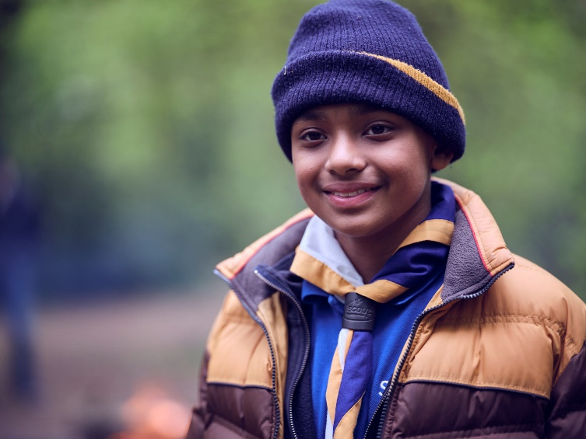

What do Scouts do?

Scouts take part in a wide range of activities as diverse as kayaking, abseiling, expeditions overseas, photography, climbing and zorbing. As a Scout you can learn survival skills, first aid, computer programming or even how to fly a plane. There’s something for everyone. It’s a great way to have fun, make friends, get outdoors, express your creativity and experience the wider world.

What do volunteers do?

Helping young people develop skills for life is only possible thanks to our team of adult volunteers, who support Scouts in a wide range of roles from working directly with young people, to helping manage a local community based Group, to being a charity Trustee. We help volunteers get the most out of their experiences at Scouts by providing opportunities for adventure, training, fun and friendship.

Our award winning training scheme for volunteers means that adults get as much from Scouts as young people. Our approach focuses on what you want to get out of volunteering with Scouts, while respecting how much time you can offer. Over 90% of Scout volunteers say that their skills and experiences have been useful in their work or personal life.

Our strategic plan

By 2023 we will have prepared more young people with skills for life, supported by amazing leaders who deliver an inspiring programme. We will be growing, more inclusive, shaped by young people and making a bigger impact in our communities.

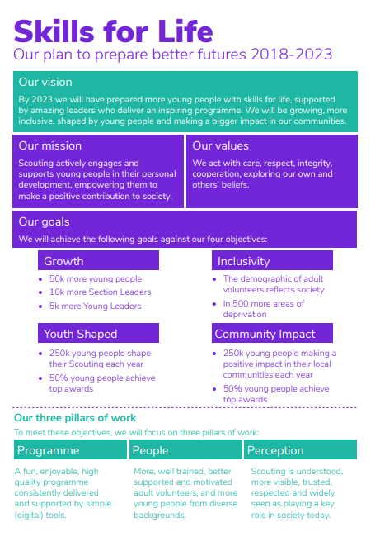

Society is changing. In often fragmented communities, the pressures and expectations on young people are increasing. The future is uncertain. Scouts has never been so important in helping young people prepare for the future, developing the skills they need to succeed in a changing world. Each week almost half a million young people enjoy fun, friendship and outdoor adventure. They develop a sense of optimism and strong values as well as the leadership and team working skills that are more valuable today than ever.

Our movement achieves remarkable things. Our previous plan, Scouting for All, inspired new Groups and sections to start in an additional 834 areas of deprivation since 2013. We now help over 460,000 young people aged 6-18 (including the highest number of girls in our history) get the best possible start in life.

Now we want to go further. Skills for Life is a strategy that supports and empowers our volunteers who are the people that make Scouts a reality. It’s a strategy to bring communities together and contribute towards a better society. But most of all, it’s a strategy for young people. They deserve the best skills, the best support, and the best possible futures.

**‘I believe that Scouts empowers young people. It gives them skills to achieve the remarkable, and opportunities to develop a deeper understanding of the rapidly changing world.’**

**Tim Kidd, UK Chief Commissioner**

Our values

**Integrity**

We say what we mean and when we make a promise, we keep it.

**Respect**

We listen to others, explore our differences and work to find common ground.

**Care**

Scouts are friends to all and think of others before themselves.

**Belief**

We believe passionately in improving the lives and life chances of young people and helping them explore and develop their beliefs and attitudes.

**Cooperation**

Scouting is about teamwork. We believe that when we work together we achieve more than we can on our own.

## Our key policies

All members follow our key policies. The policies cover:

#### Child Protection

#### Equal Opportunities

#### Religion

#### Safety

These policies are fully explained on our website at <http://scouts.org.uk/about-us/key-policies/>

#### Did you know?

* 9 out of 10 parents think their children would benefit from learning skills for life
* 83% of parents think Scouts helps young people develop skills for life
* 9 out of 10 UK adults think Scouts develop empathy
* 9 out of 10 UK adults think Scouts develop active listening skills 11 of the 12 people to walk on the moon were Scouts.
* Scouts have stood on the summit of Everest and at the South Pole.
* Scouts are public spirited – all our leaders are volunteers and nearly half (47%) volunteer outside of Scouts too.
* Over 160,000 adult volunteers in Scouting learn new skills, make new friends and make a positive impact in their communities.
* We offer over 200 activities from abseiling and coding to drama and water-zorbing.
* Over a quarter of UK Scouting’s membership is female.

We're Scouts and everyone's welcome here. All genders, races and backgrounds. Every week we give almost half a million people aged 6-25 the skills they need for school, college, university, the job interview, the important speech, the tricky challenge and the big dreams: the skills they need for life.

At a time when communities are becoming more divided, we bring people together. When many young people are struggling to find purpose and belonging, Scouts helps them develop skills, confidence and a sense of hope. We inspire positive futures and help young people find their place in the world by developing the character, employability and practical skills they need to succeed.

## The role

#### Overview

* To act as a Member of the Scout Grants Committee, a sub-committee of The Strategy and Delivery Committee. Members support the Chair in supporting local Scouting, through the provision of grants to local Scouting across the UK. You will work closely with the committee chair, other committee members and colleagues at The Scouts, to ensure that we are delivering an efficient, effective and useful grant giving function for local Scouting.

|  |  |
| --- | --- |
| Role description | |
| Responsible to: | * The Chair of The Scouts Grant Committee |
| Key tasks: | * Attend Scout Grants Committee meetings and:   + Take part in making decisions about whether to award grants, and amend or withdraw funding for existing grant awards;   + Consider reports on fund, project and programme performance and help to determine actions based on them;   + Consider and advise on the continuous improvement of the grant programmes within the Committee’s remit. * Between Scout Grants Committee meetings, support the decision making process in collaboration with the relevant members of staff to make grant award decisions as appropriate. * Assist with the quarterly compliance checking of grant awards where decision making is delegated to staff. * Support the Chair, as appropriate, to contribute to the wider national work of growth and the development of Scouting, as laid out in the Scouts strategy. * Represent and promote the work of the Scout Grants Committee around the UK at appropriate conferences and other events. * Observe the policies and procedures set out for the Scout Grants Committee by the Trustee Board, the Strategy and Delivery Committee and the Committee itself, always acting with the propriety and fiduciary responsibility appropriate to the expenditure of trust funds. |
| Time  commitment: | We expect that the Committee will meet throughout the year, conducting the vast majority of its business and meetings digitally. |

|  |  |
| --- | --- |
| Person specification | |
| Skills and  abilities: | * Communicate effectively with a wide range of audiences including, senior staff, volunteers, other Committee members, and others * Effectively contribute in meetings. * Quickly assimilate a broad knowledge of Scouting’s purpose, policies, activities and structures |
| Knowledge and experience (Desirable, must have a willingness to learn and gain these experiences): | * Experience of grant administration, structures, and governance (these may be internal or external to Scouting) * Understanding of the challenges of funding in the voluntary sector * Experience of working within a membership organisation or an organisation with devolved administration at a local level * Experience of running or monitoring funded projects * Experience of chairing meetings or groups |
| Personal  qualities: | * Be inspirational and motivational to others * Be energetic and enthusiastic about the job * Be approachable at all reasonable times * Have a commitment to the Scouts Fundamentals * Have a commitment to personal development * Be Self motivated |
|  | |

## How to apply

#### Key dates

The closing date for applications is: **28 June 2021**

Successful candidates will be invited to interview on 1 July 2021 with the first meeting of the committee with new members being held on 6 July 2021 (evening).

Process

To apply for this role, please complete the online form [here](https://app.smartsheet.com/b/form/ec996f0f55b7472380f9ac96dd3fbe1d).

#### Further information

If you would like to discuss the role in more detail, please contact Frankie Smith, Chair of Scout Grants Committee on [frankie.smith@scouts.org.uk](mailto:frankie.smith@scouts.org.uk)

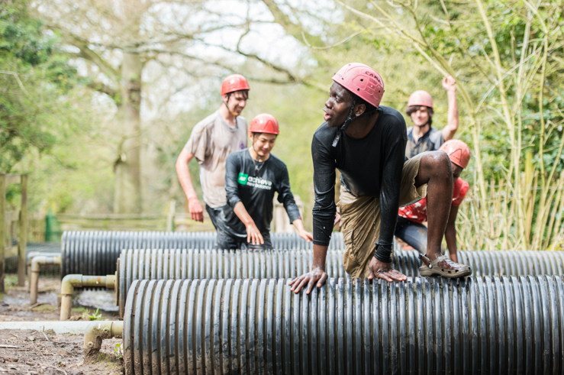



**THE SCOUT ASSOCIATION**

**Scout Grants Committee**

**TERMS OF REFERENCE**

**Members**

The group shall have a maximum of seven members comprising:

* Chair
  + appointed by the Strategy and Delivery Committee
  + appointed for a three-year term renewable for one further three-year term
* Five Independent Members who:
  + have varied and wide-ranging significant current or recent experience of Scouting, including knowledge of additional needs in young people and adult volunteers and who represent the diversity of the membership
  + are Members or Associate Members of the Association
  + have experience of, or interest in, grant giving and can work within the principles of ‘good grant giving in Scouts[1]’
  + are appointed by the Chair for a period of three years renewable for one further three-year term
  + two of these Members must be aged between 18 and 24 at the time of their appointment
* A member of Team UK and/or a Trustee

The role of Secretary of the Group will be undertaken by the Member Operations Manager at UK Headquarters.

**Quorum**

50% of the membership (subject to declaration of any conflict of interest)

**Frequency**

Normally three meetings per annum.

**Voting**

The committee will strive for consensus around matters which require a decision. In the absence of consensus, matters arising at any meeting shall be decided by a majority of votes of those present (see Quorum above). In case of any equality of votes, the Chair shall not have a second or casting vote. Instead, the motion must be deemed not to have been carried.

**Rights of attendance**

The Chair of the Board of Trustees, all members of the Board and the Chief Scout have right of attendance in a non-voting capacity. Any others, by prior notice to and with the permission of the Chair, may also attend in a non-voting capacity.

In addition the Committee may need to call on relevant experts to inform discussions/decisions as and when necessary.

**Remit**

The Committee is responsible to the Strategy and Delivery Committee for the delegated responsibilities from the Strategy and Delivery Committee including:

1. To be custodians of the criteria and requirements for the restricted funds open to members of the movement that are considered HQ Grants, (see current list attached).
2. Review and recommend changes to the terms of grants where the restrictions may no longer be of benefit to the Scouts in the way intended due to changes in society etc.
3. Provide governance oversight of restricted funds, with fiduciary responsibility to ensure the Scouts are meeting the needs of the funder/s (and reassure the Strategy and Development Committee this is happening)

Ensuring:

* compliance with any awarding criteria applicable to the relevant designated/restricted fund(s) providing equitable distribution of funding so that there is no bias from individual staff or volunteers in the allocation of funds
* that appropriate governance and audit arrangements are operated by HQ in relation to these funds
* specialist advice and recommendations are sought where appropriate
* that, as appropriate, the outcomes and impact of approved grants are monitored and reviewed and learning disseminated
* all appeals are reviewed and dealt with.

1. Be proactive in the promotion of the Grants available from HQ by providing advice, support and guidance material, webinars and attending conferences and events.
2. Ensuring grants of £10,000 and over, considered large grants, are operating in line with the grant agreement. This can include visiting projects and receiving written reports. Ensure action is taken quickly where concerns are identified.
3. Ensuring grants under £10,000 are operating in line with fund criteria, by receiving reports from staff and occasionally beneficiaries and ‘spot-checking’ the assessment of all funds every four months to ensure criteria are being applied fairly and any auditing requirements are being met.
4. To be the source of advice to HQ and its committees in relation to the disbursement of key funds that aid the growth and development of Scouting in the UK and in BSO.
5. To provide an annual report to the Strategy and Delivery Committee and to the Finance Committee.

**Reporting**

Minutes of all Committee meetings, or a summary of the Minutes approved by the Committee Chair, will be circulated to the Strategy and Delivery Committee.

**Funds considered HQ grants**

**Scout funds**

2021 ring-fenced membership fee fund

Future Growth Fund

Inclusion Fund for World Events

**Living donors**

RMTGB (Better Prepared), created 2015

Milly Apthorp Charitable Fund, created 2010

Alpkit Foundation

Ralph Reader Memorial Support Fund (London Gang Show liaison)

Trinity House Sea Scouts, created 2004

Sea Scouts Admiralty, created 1942

Shipwrights Fund

**Deceased donors**

Benevolent Fund, created 1922

Cornwell Memorial, created 1916

International Fund, created 1929

John Weedon, created 1950

Sea Scouts General, created 1924

Additional Needs Fund (Special Needs Fund), created 1949

WT Taylor Air Scouts, created 1987

Ralph Reader Memorial Endowment Fund, created 1982 (interest transferred to the Ralph Reader Memorial Support Fund)

Ralph Reader Memorial Trust Fund, created 1982 (held on trust until 2030 then transferred to the Ralph Reader Memorial Support Fund)

Drafted: November 2020

Approved:

Next review date: TBA

**Version Control**

V1 – November 2020 – Adam Curtis draft

V2 – December 2020 – Emma Newstead edits

V3 – January 2021 – Debbie Ladds edits

V4 – January 2021 – Emma Newstead edits

V5 – January 2021 – Edits from SGC meeting

V6 – January 2021 – Edits from feedback: Graeme Hamilton and Wendy Human

V7 – March 2021 – removed King George fund as result of Board decision

1. Principles of good grant giving in Scouts to be proposed by SGC and agreed by SDC in April 2021