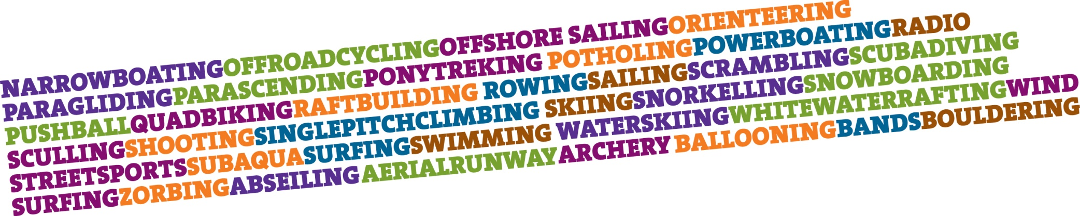
PRESS RELEASE...

UNDER EMBARGO UNTIL

Date: DD/MM/YYYY

(INSERT NAME OF SCOUT GROUP) thanks (INSERT NAME and title) for visiting and speaking to the Group.

(INSERT NAME OF GROUP) were delighted to have the pleasure of (INSERT NAME OF SPEAKER) visiting their Group on (INSERT DATE) where they gave a talk and presentation on (INSERT INFORMATION)

(INSERT INFORMATION ON TALK LINKING IT BACK TO THE SCOUT BRAND AND KEY MESSAGES)

(INSERT NAME OF SCOUT LEADER) said “(INSERT QUOTE REINFORCING KEY MESSAGES) “

(INSERT NAME OF YOUNG PERSON) said “(INSERT QUOTE EXPRESSING THE YOUNG PERSON ENTHUSIASM FOR SCOUTING)“

(INSERT NAME OF GUEST SPEAKER) said “(INSERT QUOTE EXPLAINING WHY THE SPEAKER VOLUNTEERED THERRE TIME FOR SCOUTING)“

Scouting is shaped by young people in partnership with adults and we are always looking for new volunteers and if you fancy a go at (INSERT LOCATION) why not join the adventure at www.scouts.org.uk/join.

ENDS

For further information please contact (INSERT NAME, MOBILE NUMBER AND EMAIL ADDRESS OF LOCAL CONTACT)

ABOUT SCOUTING

- The Scout Association was founded on 1st August 1907.
- Adventure is at the core of Scouting, and the Association passionately believes in helping their members fulfil their full physical, intellectual social and spiritual potentials by working in teams, learning by doing and thinking for themselves.
- Over 200 activities are offered to the half a million Scouts around the UK, made possible by the efforts of 100,000 voluntary adult leaders. This has helped make Scouting the largest co-educational youth Movement in the country.
- One of the challenges that the Scout Movement faces is finding more volunteers to plug the current gap. At present there are nearly 38,000 young people on waiting lists as more and more young people want to experience the adventure of Scouting.
- Adults working in Scouting contribute in excess of 364 million hours of voluntary work each year to their local communities.
- The number of volunteers working for Scouting is bigger than the combined workforces of the BBC (24,000) and McDonalds (67,000) put together.
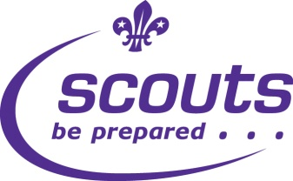
- Worldwide Scouting has 30 million members both male and female and operates in nearly every country in the world.
- There are half a million members across the UK (400,000 young people supported by 100,000 adult volunteers). Worldwide Scouting has 28 million members both male and female and operates in nearly every country in the world.
- There are 200 Scout activity and challenge badges. These require participants to achieve a level of understanding and skill determined to be realistic for their age group.
- There are (INSERT NUMBER OF YOUNG PEOPLE IN GROUP) young people in (INSERT GROUP NAME) support by (NUMBER OF ADULTS) who support the work of the Group.
- Activities undertaken in the last year include; xxxxxxxxxxxxxxxxxxx
- Activities planned for the next 18 months include; xxxxxxxxxxxxxxxx

