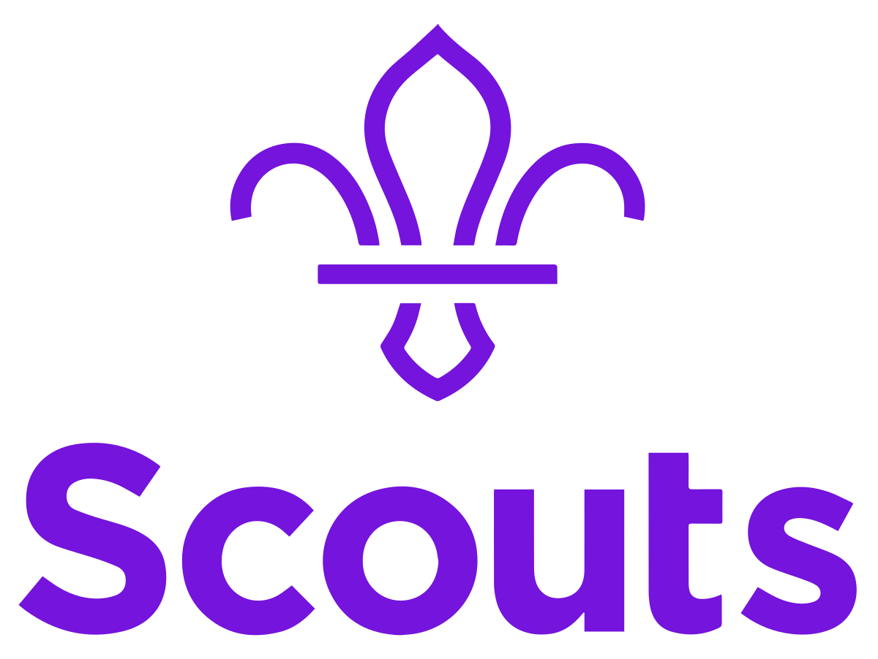
Address 1
Address 2
City
Postcode
Date

To whom it may concern, (if you know the person’s name, put it here instead)
I hope this letter finds you well. As you may be aware, I/we have been invited to participate in the World Scout Moot 2022, as a member of the UK Contingent. The World Scout Moot is an international Scout camp organised by the World Organisation of the Scout Movement for young people aged 18-26. Similar to a World Scout Jamboree, the Moot is an opportunity for young people to discover more about international cultures, make new friendships both within the UK and from overseas and, perhaps most importantly, develop key skills for life: independence, character and curiosity.
The 16th World Scout Moot is taking place across the island of Ireland in 2022 for over 5,000 Scouts, organised by Scouting Ireland. Unlike World Scout Jamborees, the Moot is organised on an individual basis with participants joining mixed international patrols throughout the event.
[The two paragraphs below are for Participants. IST members should delete them]
A Moot is meant to be different from any other international camp – it’s the ultimate adventure! As a participant, I’ll spend the first half of the Moot on a "Trail" in a patrol made up of Scouts from different nationalities. This means that I might be the only one who speaks fluent English or the only one who appreciates a good cup of tea in the morning. Together with my patrol, we’ll learn more about each other and Ireland as we set off on an adventure we’ve picked. This could be surfing on Ireland’s west coast, cycling across the island or working on a sustainability project at a local campsite – the choice is up to us.
After that, all participants will come together at the basecamp in Malahide, just outside of Dublin. Here, we’ll still camp with our patrol, experiencing living together with over 5,000 other Scouts – meeting both old and new friends, taking part in global development sessions and exploring Dublin.
[The paragraph below is for IST members. Participants should delete it]
A Moot is meant to be different from any other international camp – it’s the ultimate adventure! As a member of the International Service Team (IST), I will be one of a dedicated legion of Scouting volunteers aged 27+ who will assist with the organisation of the event. This could be anything from helping on the trails, camp security, running sessions at basecamp or being roving reporters for the Moot newspaper. What will remain the same is the opportunity to work alongside new people, learning from them and bringing new skills, games, activities and ideas back to local Scouting in [WHERE YOU LIVE].
After an application process, I/we have been selected to be a participant/IST representing [WHERE YOU LIVE] at the Moot. Between now and summer 2022, we will be working to gain the necessary skills to get the most out of the experience.
The cost of attending the Moot is [PRICE] – I was/we were wondering if [NAME OF COUNTY/DISTRICT/GROUP] would be able to support me/us in order that I/we can take part this life-changing experience. I/we would be more than happy to let you know more about Moot both before and after the event in order to spread the message about international Scouting to others in the Group/District/County.
If you have any questions or queries, please do not hesitate to get in touch with me/us.
Kind regards,

YOUR NAME(S) HERE

