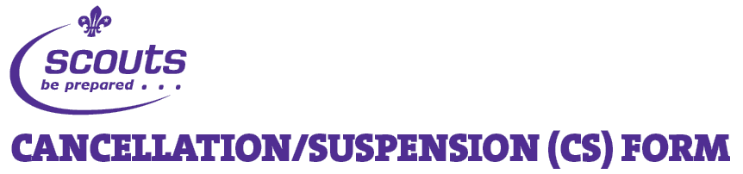

This form should be used if you are cancelling an appointment for an unsatisfactory reason or if you are suspending an adult from Scouting. If an appointment is being cancelled for a satisfactory reason (i.e. the person has moved area or wishes to leave Scouting), please cancel their appointment using the online tools at www.scouts.org.uk.

Membership number (if known)

Surname

Forename

Date of birth

Address
Post Code
Telephone (daytime)
Telephone (home)
Mobile
Email Address

Role held:
Group:
District:
County/Area/Region (Scotland):

Please tick only one option either ‘Suspension’ or ‘Cancellation’

Allegation of criminal offence

Dispute between adults

Serious breach of Association rules

Reputation of the Association

Date of commencement of suspension

Failed to perform duties

No longer accepts principles

Dispute between adults

Serious breach of Association rules

Serious criminal allegation/conviction

Inappropriate behaviour

Training obligations not met

Date of commencement of suspension

Relevant information about the reason for the cancellation or suspension must be outlined on the reverse side of this form.

District Commissioner

Date

The completed and signed form should be marked ‘Private and Confidential’ and sent to:

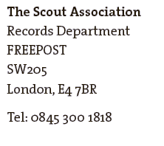

Copyright © December 2009 The Scout Association Registered Charity Numbers 306101 (England and Wales) and SC038437 (Scotland)

County/Area/Regional Commissioner

Date

