## **Invitation letter**

Dear……………………………………………. Date…………………………………………….

Thank you for expressing an interest in becoming a volunteer with the Scouts. To start your application process we need to arrange to meet to enter your details onto the Scouts database (Compass) and complete your AccessNI online application.

The completion of the AccessNI check is an important part of keeping young people in Scouting safe, we recognise that if you have a criminal record this is not a automatic bar to obtaining a position. We use a risk based approach to our safeguarding and vetting decisions, further guidance can be found in [POR: The Appointments Process](https://members.scouts.org.uk/supportresources/71) on our website. We will keep certain types of information for different periods of time in line with our [retention policy](https://scouts.org.uk/media/980613/REP-Retention-Policy-Web-Version-v25.pdf).

The Scout Association’s Data Protection Policy can be found [here](http://www.scouts.org.uk/por) and the Data Privacy Notice [here](https://scouts.org.uk/privacy-policy/).

Could we please arrange to meet:

**Date: Time: Venue:**

Before this meeting you need to create an AccessNI NI Direct online account to enable your AccessNI online application to be completed during our meeting. See pages 3 & 4 for step by step instructions.

If you don’t have an email address an email account could be created in your name using a free online account such as gmail or hotmail.

Please bring the following to the meeting:

1. Your AccessNI NI Direct login details (email address and password).

2. Three documents must be provided in the name of the applicant; **one from Group 1 and two from Groups 1 or 2a or 2b**. At least one document must show the applicant’s current address. If this is not possible, then **four documents from Group 2a** and **2b** should be produced, one of which being a birth certificate issued after the time of birth. One document must show the applicant’s current address.

Note: When checking all 3 ID documents, you must take all the names from all the documents and include them in the application.

3. National Insurance number.

4. Driving licence number (if you hold one).

5. Passport number (if you hold one).

6. Your address(es) for the last five years.

7. Details of referees if applicable (please complete the section on page 2). Please note references are not required for Occasional Helpers.

|  |  |  |  |
| --- | --- | --- | --- |
| **GROUP 1 : Primary identity documents** | | | |
|  | Current passport (any nationality) |  | Original birth certificate (UK, Isle of Man or Channel Islands) issue at time of birth |
|  | Biometric Residence Permit (UK) |  | Original long form Irish birth certificate –issued at time of registration of birth (Ireland) |
|  | Current driving licence (UK, Ireland, Isle of Man, Channel Islands or any EEA country) |  | Adoption certificate (UK, Isle of Man or Channel Islands) |
| **GROUP 2a : Trusted government documents** | | | |
|  | Birth certificate (UK, ROI, Isle of Man or Channel Islands) issued after time of birth |  | Electoral ID card (NI only) |
|  | Marriage / Civil Partnership Certificate (UK, Ireland, Isle of Man or Channel Islands) |  | Current driving licence photocard, full or provisional (All countries outside the EEA) |
|  | HM Forces ID card (UK) |  | Current driving licence (full or provisional paper version (if issued before 1998) (UK, Isle of Man, Channel Islands, EEA) |
|  | Firearms licence (UK, Channel Islands and Isle of Man) |  | Immigration document, visa or work permit (issued by a country outside the EEA – valid only if the applicant is working in the country that issued the document) |

|  |  |  |  |
| --- | --- | --- | --- |
| **GROUP 2b : Living and social history documents** | | | |
|  | Mortgage Statement (UK, EEA) |  | Land and Property Services rates demand (NI only) |
|  | Financial statement, for example ISA, pension or endowment (UK) |  | Council tax statement (Great Britain, Channel Islands) |
|  | P45 or P60 statement (UK, Channel Islands) |  |  |
| **Above documents must be issued within the last 12 months** | | | |
|  | Credit card statement (UK,EEA) |  | Bank or building society account opening confirmation letter (UK, EEA) |
|  | Bank or Building society statement (UK, EEA) |  | Utility bill (not mobile phone) (UK, EEA) |
|  | Bank or Building society statement (Outside EEA) (Branch must be in the country where the applicant lives and works) |  | Benefit statement, for example Child Benefit, Pension, etc (UK, Channel Islands) |
|  | Central or local government, government agency, or local council document giving entitlement, for example from the Department for Work and Pensions, the Employment Service, HMRC (UK, Channel Islands) | | |
| **Above documents must be issued within the last 3 months** | | | |
|  | EU National ID card |  | Cards carrying the PASS accreditation logo (UK, Isle of Man, Channel Islands) |
|  | 60+ or Senior (65+) SmartPass issued by Translink (NI) |  | Letter from head teacher or further education college principal (UK for 16 -19 year olds in full time education – only used in exceptional circumstances if other documents cannot be provided) |
|  | yLink card issued by Translink (NI) |  | Letter of sponsorship from future employment provider or voluntary organisation (non-UK or non-EEA only for applicants residing outside UK at time of application) |
| **Above documents must be valid at the time of checking** | | | |

**References (References are not required for Occasional Helpers)**

Please add details of two people to act as referees who are known to you and who can be contacted by email. The referees should preferably have knowledge of your work or contact with young people and should be able to comment on your character and relationships with others. At least one referee should have known you for at least five years and one of the referees must not be from Scouting. Referees must not be relatives. Examples of referees include your employer, college tutor, etc. The referees’ personal data will only be used for the purposes of providing a reference.

|  |  |
| --- | --- |
|  | I can confirm that I have been given permission to provide the referees’ personal data. |

|  |  |
| --- | --- |
| Referee No. 1 Name | Relationship |
| Email | Phone Number |
| Address | Postcode |

|  |  |
| --- | --- |
| Referee No. 2 Name | Relationship |
| Email | Phone Number |
| Address | Postcode |

A copy of our policy on the recruitment of ex-offenders is available on request from The Scout Information Centre.

Access NI Code of Practice can be accessed via the Access NI website - <https://www.nidirect.gov.uk/publications/accessni-code-practice>

To create an NI Direct AccessNI online account, open this web address:

<https://accessni.nidirect.gov.uk/account/login>

Click on the Green Create an account button.

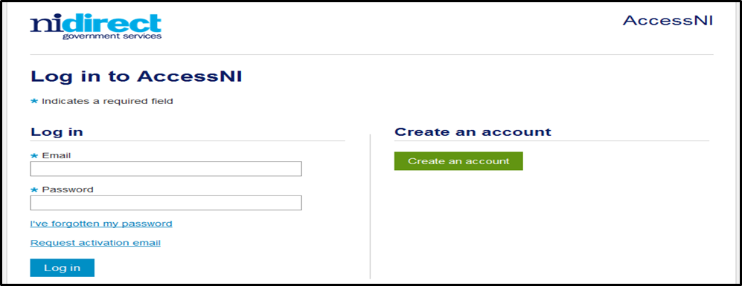

Complete the details on this form to create an account.

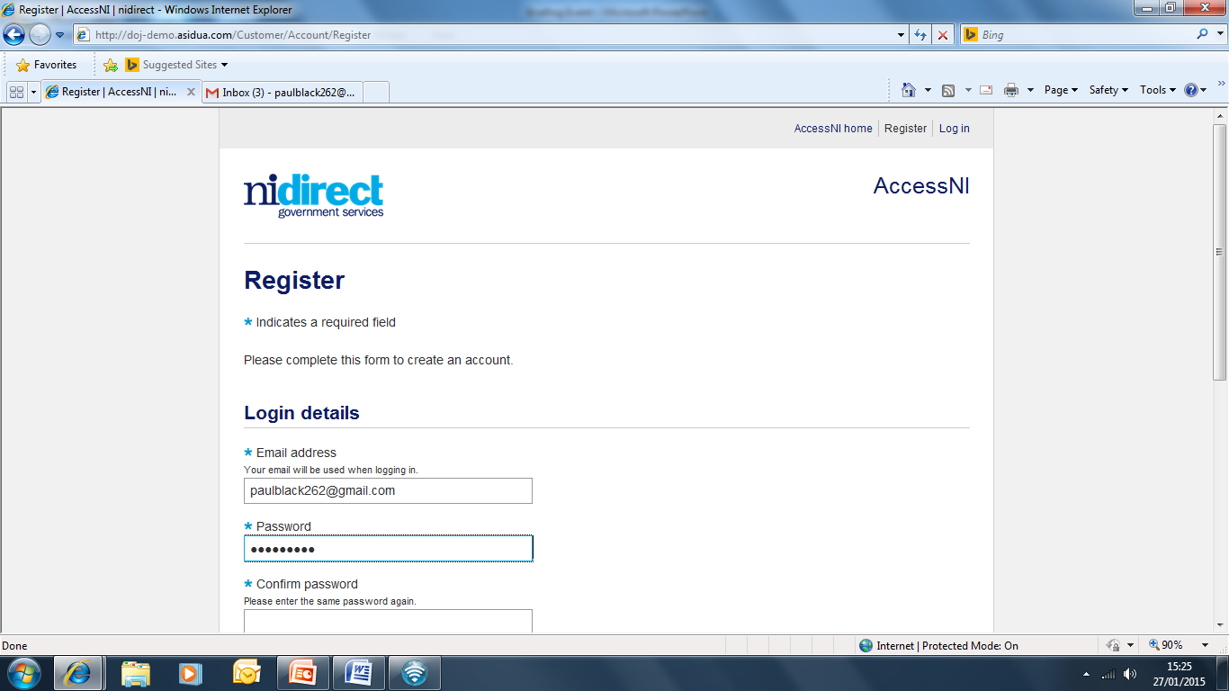

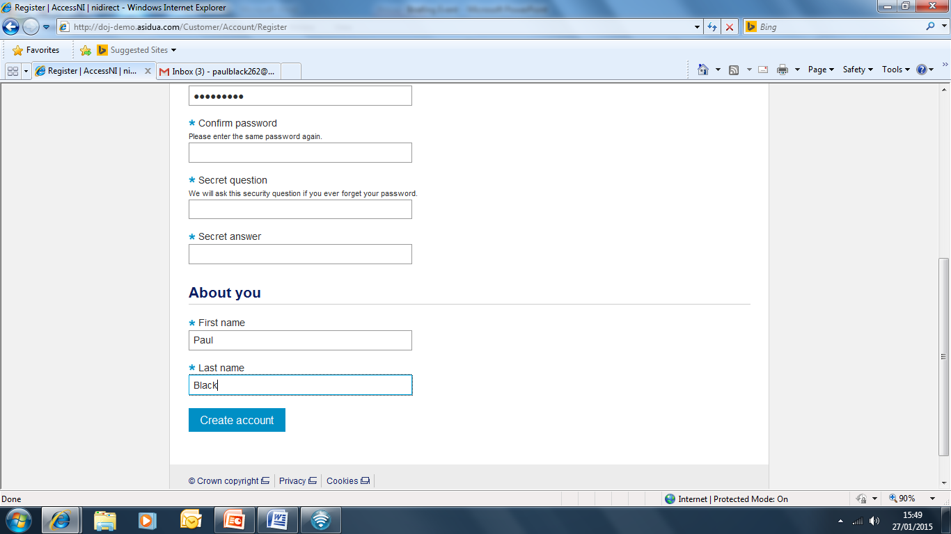

Click on Create account

Take a note of your email address and password as you will need this for completing your online application during the meeting with your Group Scout Leader.

This screen will then appear

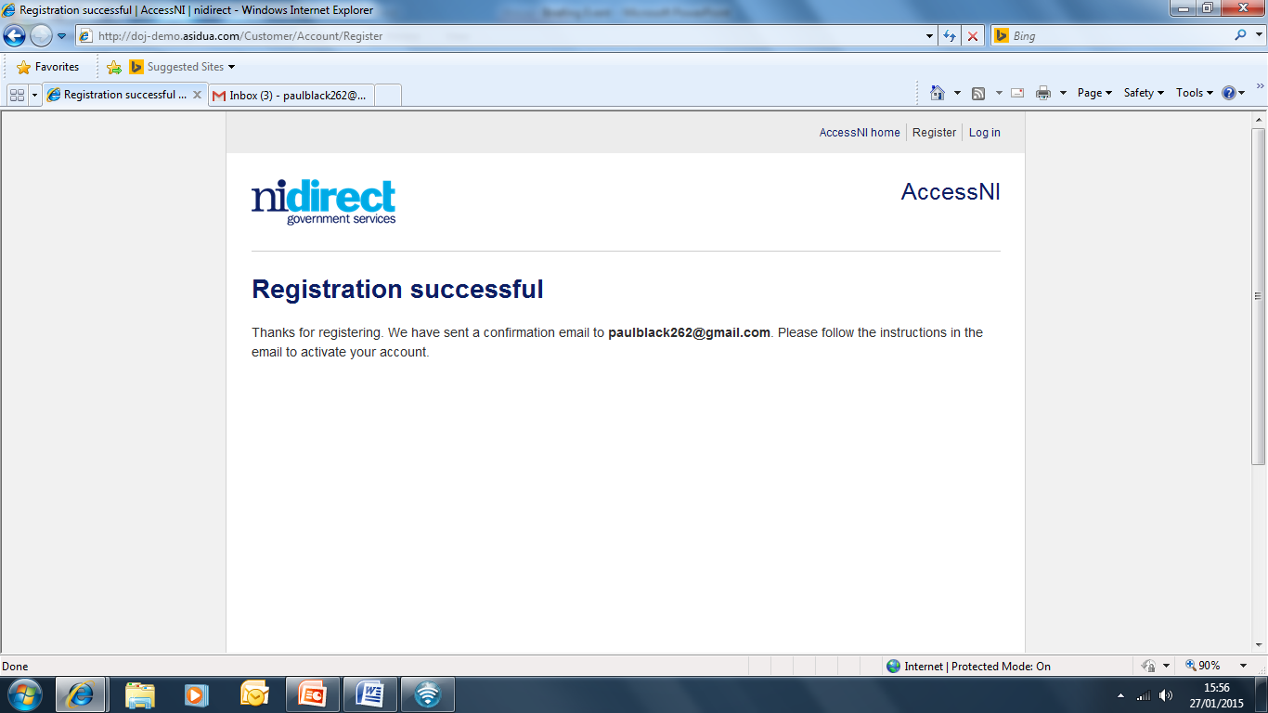

You need to log into your own email inbox where you will find a new email from AccessNI the content of which is as follows:

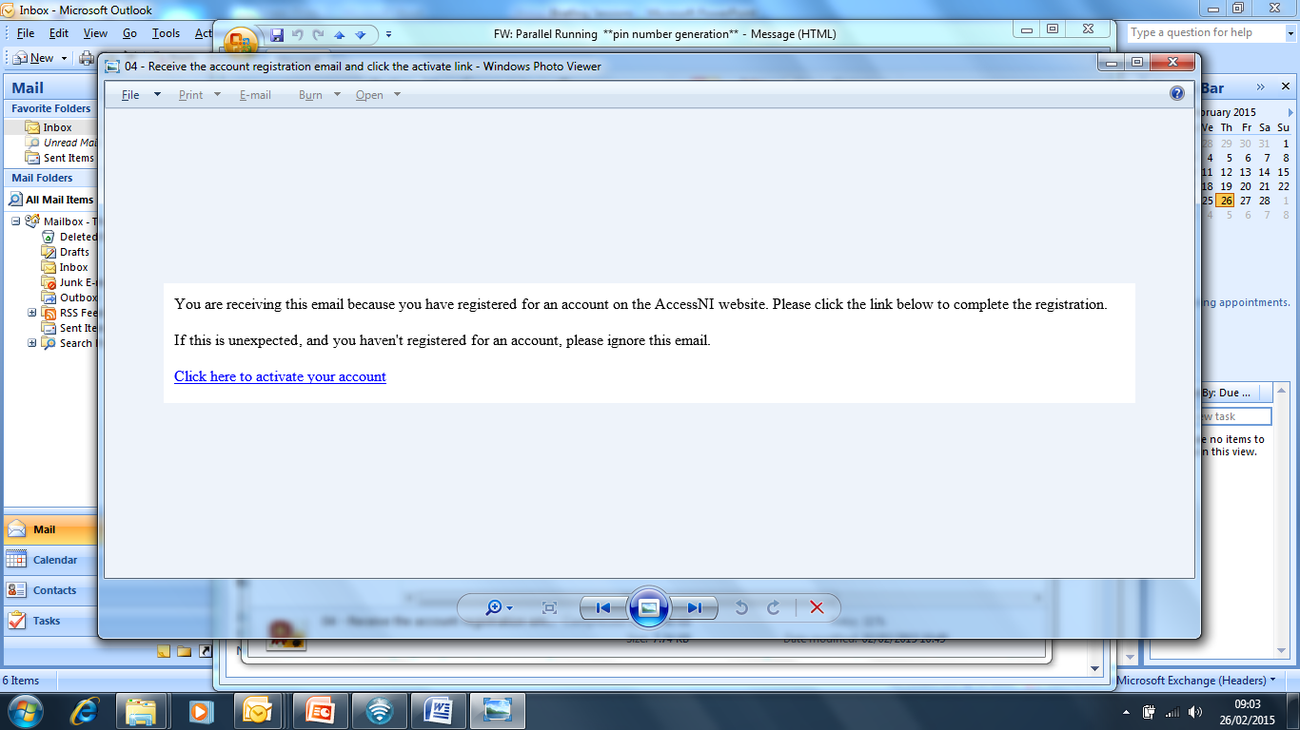

Click here to activate your account.

The remainder of your AccessNI online application will take place during the meeting with your Group Scout Leader.

When all 3 ID documents are checked, all the names from all the documents must be included in the application.

