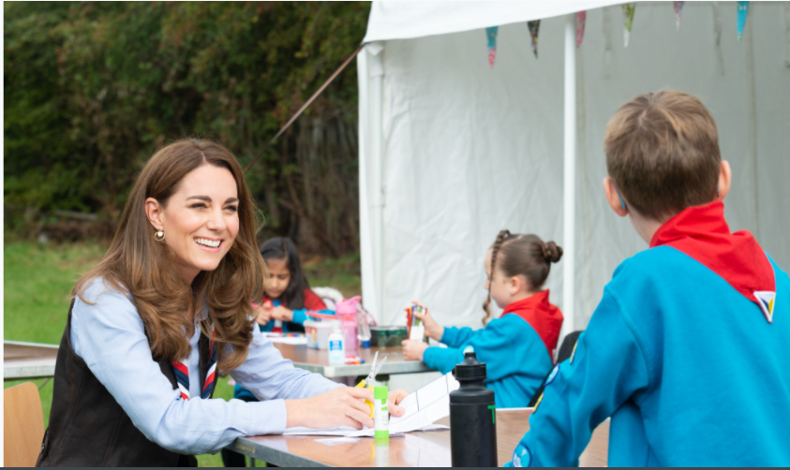

Junior Media Relations Officer

Applicant Information Pack

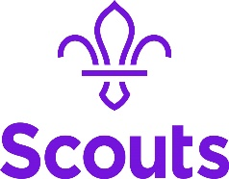
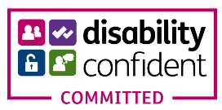

About us 3
Our strategic plan 4
Our structure 5
Job Description 6
Benefits 7
How to apply 8

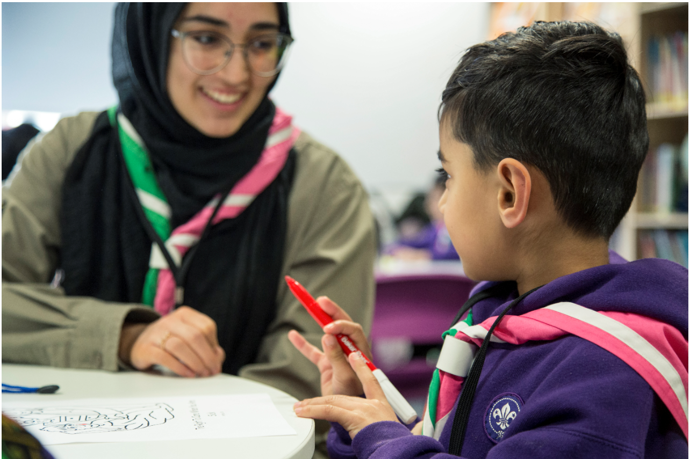

About us

We're Scouts and everyone's welcome here. All genders, races and backgrounds. Every week we give almost half a million people aged 6-25 the skills they need for school, college, university, the job interview, the important speech, the tricky challenge and the big dreams: the skills they need for life.
At a time when communities are becoming more divided, we bring people together. We encourage our young people to do more, learn more and be more. We’re a worldwide movement, creating stronger communities and inspiring positive futures. We welcome talent from all backgrounds and your contribution to help even more young people succeed in life.
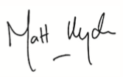
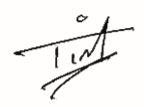

Tim Kidd, UK Chief Commissioner Matt Hyde, Chief Executive

Our Values

Integrity Respect Care
Belief Cooperation
Our strategic plan
By 2025 we will have prepared more young people with skills for life, supported by amazing leaders who deliver an inspiring programme. We will be growing, more inclusive, shaped by young people and making a bigger impact in our communities.

Society is changing. In often fragmented communities, the pressures and expectations on young people are increasing. The future is uncertain. Scouts has never been so important in helping young people prepare for the future, developing the skills they need to succeed in a changing world. Each week almost half a million young people enjoy fun, friendship and outdoor adventure. They develop a sense of optimism and strong values as well as the leadership and team working skills that are more valuable today than ever.
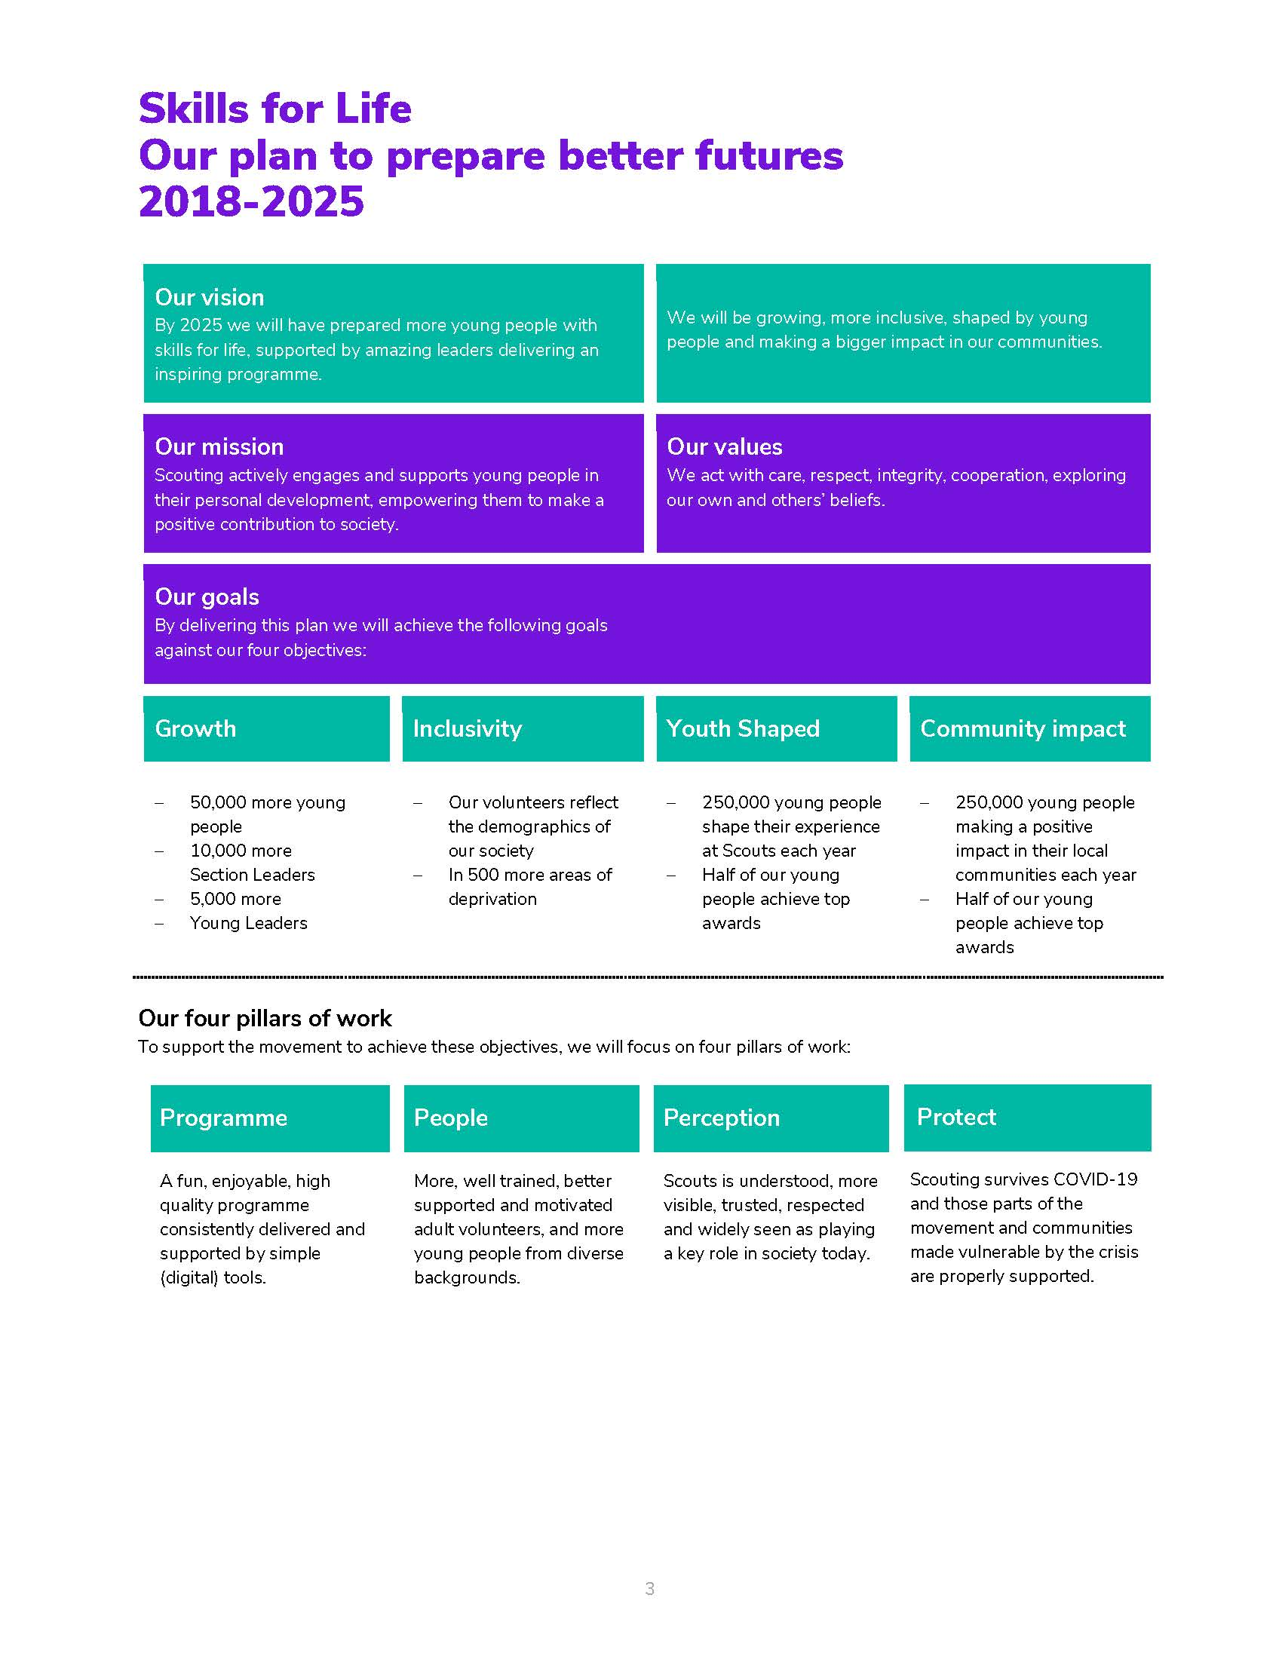
Our movement achieves remarkable things. We have continued to grow for 13 consecutive years. Our previous plan, ‘Scouting for All’, inspired new Groups and sections to start in an additional 834 areas of deprivation since 2013. We now help over 462,000 young people aged 6-18 (including 102,000 girls) get the best possible start in life. Our social action campaign, A Million Hands, has enabled over 200,000 young people to make a positive contribution in their local communities.
Now we want to go further. Skills for Life is a strategy that supports and empowers our volunteers who are the people that make Scouts a reality. It’s a strategy to bring communities together and contribute towards a better society. But most of all, it’s a strategy for young people. They deserve the best skills, the best support, and the best possible futures.

‘I believe that Scouts empowers young people. It gives them skills to achieve the remarkable, and opportunities to develop a deeper understanding of the rapidly changing world.’ Tim Kidd, UK Chief Commissioner

The Scouts Structure
The UK headquarters of the Scouts is based at Gilwell Park, Chingford, London, and is operationally divided into four directorates
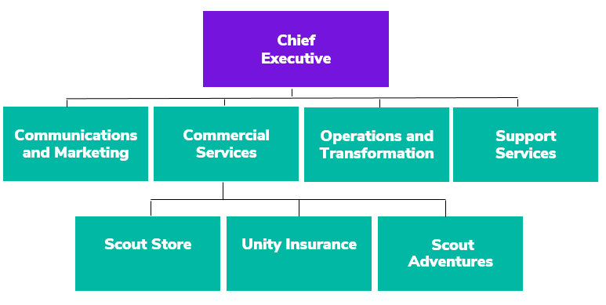

Team Structure Chart

Job Description – Junior Media Relations Officer

Responsible to: Media Relations Manager

Department: Communications and Marketing/Media Relations

Base Location: Gilwell Park, Chingford

Term: Permanent

Salary: £21,875, inclusive of OLW - Band B

Hours: 35 hours per week

Line Management Responsibility: N/A

Budgetary responsibility: N/A

Internal Relationships: Celebrity Ambassadors, volunteers and all Association staff

External Relationships: Media contacts including journalists, planners and producers, contacts at partners, funders, charities and agencies

DBS: Basic

Core Purpose

You will help deliver media campaigns to share inspiring stories through the media about young people and adults learning skills for life through Scouting. As a super-motivated, energetic member of our award-winning Media Relations team you will be working directly with journalists across the UK from local media through to national news.
As our Junior Media Relations Officer you’ll play a key role in a busy team. You will be supporting the team to spot opportunities, create and source content and liaising with media on a wide range of campaigns and events. You are calm under pressure and able to meet deadlines, with a desire to succeed.
You will be joining a team that is passionate, creative and loves what we do. We are always looking for inspirational stories and new ways to showcase them. We pride ourselves in providing excellent training and support to match your career aspirations, making this a perfect environment to learn and grow your PR and press office skills. The role brings the opportunity to complete a Level 4 Higher Apprenticeship in Public Relations, an equivalent qualification to a Foundation degree.

Key Accountabilities
Contribute to and support media relations campaigns that develop the Scout brand and reflect our values
Provide responses to media enquiries ensuring journalists receive timely and accurate information
Pitch positive news stories and secure coverage that communicates key messages in local media outlets
Research case studies and analyse data to generate storylines that can raise the profile of the Scouts in the media
Develop assets such as press releases and social media content to support campaigns
Create and maintain media lists and manage press release distribution
Build and grow working relationships with media contacts across print, broadcast and online, consumer and charity media. Maintain an understanding of the evolving media landscape.
Liaise with colleagues, volunteers and partners to produce pitches and content as directed by the Media Relations Manager
Monitor and evaluate coverage, including audience, key messages and data analysis to inform planning and future campaigns
Support the broader work of the Scouts, including out of hours working and travel across the UK as required.
Undertake other duties or special projects as defined by the Media Relations Manager

Person Specification

Experience

This entry-level role is perfect for you if you love working with people and telling inspiring stories. You will be full of creative ideas and eager to contribute to the work of the team.

We are looking for an organised and motivated individual with good communication and collaboration skills.

Working with media outlets and volunteers involves working out of office hours and flexibility is essential for this role.

Skills, Abilities & Knowledge
- Clear writing and editing skills, with a strong grasp of spelling and grammar
- Confident verbal communicator able to pitch ideas and negotiate
- Creative thinker able to craft stories that put the audience’s interests first
- Proven ability to manage own time and prioritise workload in a busy environment to deliver to tight deadlines
- Strong interpersonal skills to build rapport, establish credibility and maintain effective working relationships with people of all ages and diverse backgrounds
- Ability to persist through challenges and take personal responsibility for solving a problem or make the most of an opportunity
- Experience working collaboratively with people who have different goals to achieve a shared objective
- Interest in current affairs and awareness of the news agenda
- Experience using Microsoft Office package and abilty to learn new products
- Experience of content editing tools for image, audio and video content, or a willingness to learn
- Experience creating content for social media, with an understanding of content formats and how audiences use different platforms, and a commitment to staying current

Values & Personal Qualities
- Motivated to learn, can absorb information quickly and accept and act on constructive feedback
- An approachable personality who responds to stakeholders needs
- Adaptable and ﬂexible in responding to changing priorities
- Ability to communicate credibly with a range of stakeholders

Benefits
We’ve got some great benefits
Holiday Entitlement: On top of your generous 25 days annual leave we give you up to three extra days off between Christmas and New Year. And that’s not all, holiday goes up to 28 days after 2 years’ service and 32 days after 5 years’ service (pro rata for part time staff)

Looking after your health and well-being
Simply Health scheme: Optical, dental and many more appointments covered, as well as great gym and family days out discounts.

Sickness absence: Once you’re three months in, we have generous sickness pay, above the statutory.
Wellbeing walks: Scheduled once a month at Gilwell Park, this a great chance to take an hour out of work to walk in the beautiful countryside with colleagues, taking in the fresh air.

Looking after your future

Pension Scheme: We look after your future. You will have been automatically enrolled into The Scout Association’s Group Personal Pension Plan, contributing 3% of your qualifying earnings. The Scouts will contribute double at 6% of your qualifying earnings on auto enrolment. You can increase your contribution at any point and we will double your contribution up to a maximum of 10% of your gross salary.

Looking after your family: Your loved ones will receive four times the basic salary if you pass away while employed by us.

Getting to and from work

Car parking: Parking is free at all our sites.

Minibus Service: When working at Gilwell Park, a minibus can collect you at various times from Chingford Station and drop you back at various times.

We are proud to be a family friendly employer

Personal Days: Up to four personal days paid leave a year.

Maternity/Paternity Leave: We pay maternity leave above the statutory minimum requirement.
Start and ﬁnish time: Employees can apply for some ﬂexibility on their start and ﬁnish times of work.

Making your money go that little bit further

Scout Store purchases: You can buy Scout Store merchandise with a discount of 25% on certain items.
Online beneﬁts portal: Our online beneﬁts portal allows you to tailor make your own beneﬁts package.

Developing yourself and others

Study and volunteer leave: Special leave includes paid leave for volunteering and study leave.

How to apply

Before making an application please ensure that you have read the Recruitment and Selection policy:
https://scouts.org.uk/media/1009429/Recruitment-and-Selection-Policy.pdf

You can read more about working at Scouts here: https://scouts.org.uk/about-us/jobs/working-at-the-scouts/
We would be grateful if you would also complete the Recruitment Monitoring questions on the Application Form. Our Equal Opportunities policy can be found here: https://www.scouts.org.uk/por/2-key-policies/equal-opportunities-policy/
The closing date for applications is 16th May 2021
The interviews will be held on 1st June
If you would to discuss the role in more detail, please contact Recruitment@Scouts.org.uk

To submit an application, please use this Smartsheet Link:
https://app.smartsheet.com/b/form/405e5cdb865247c8a9e25b6efb3f6b7c

