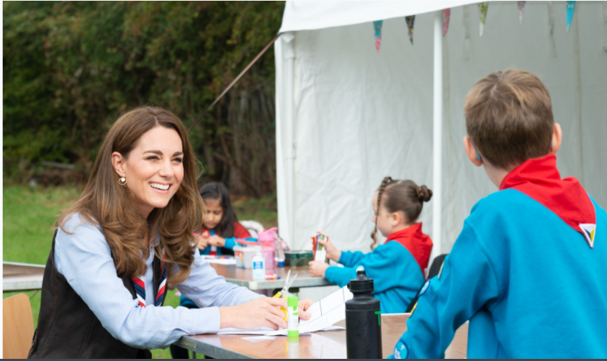

Product Manager (CRM)

Applicant Information Pack

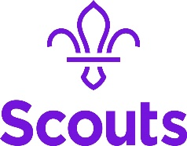
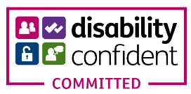

About us 3
Our strategic plan 4
Our structure 5
Job Description 6
Benefits 7
How to apply 8

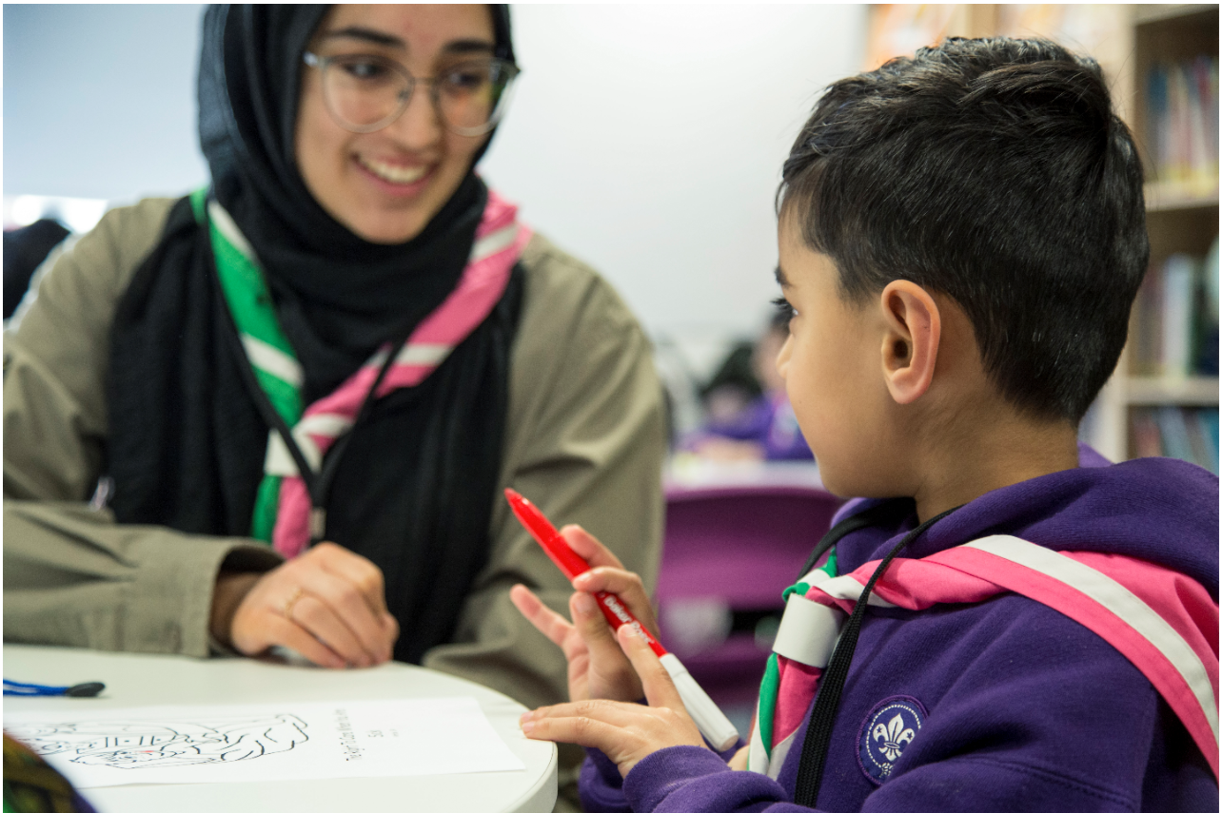

About us

We're Scouts and everyone's welcome here. All genders, races and backgrounds. Every week we give almost half a million people aged 6-25 the skills they need for school, college, university, the job interview, the important speech, the tricky challenge and the big dreams: the skills they need for life.
At a time when communities are becoming more divided, we bring people together. We encourage our young people to do more, learn more and be more. We’re a worldwide movement, creating stronger communities and inspiring positive futures. We welcome talent from all backgrounds and your contribution to help even more young people succeed in life.
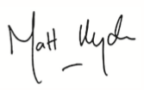
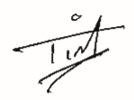

Tim Kidd, UK Chief Commissioner Matt Hyde, Chief Executive

Our Values

Integrity Respect Care
Belief Cooperation
Our strategic plan
By 2025 we will have prepared more young people with skills for life, supported by amazing leaders who deliver an inspiring programme. We will be growing, more inclusive, shaped by young people and making a bigger impact in our communities.

Society is changing. In often fragmented communities, the pressures and expectations on young people are increasing. The future is uncertain. Scouts has never been so important in helping young people prepare for the future, developing the skills they need to succeed in a changing world. Each week almost half a million young people enjoy fun, friendship and outdoor adventure. They develop a sense of optimism and strong values as well as the leadership and team working skills that are more valuable today than ever.
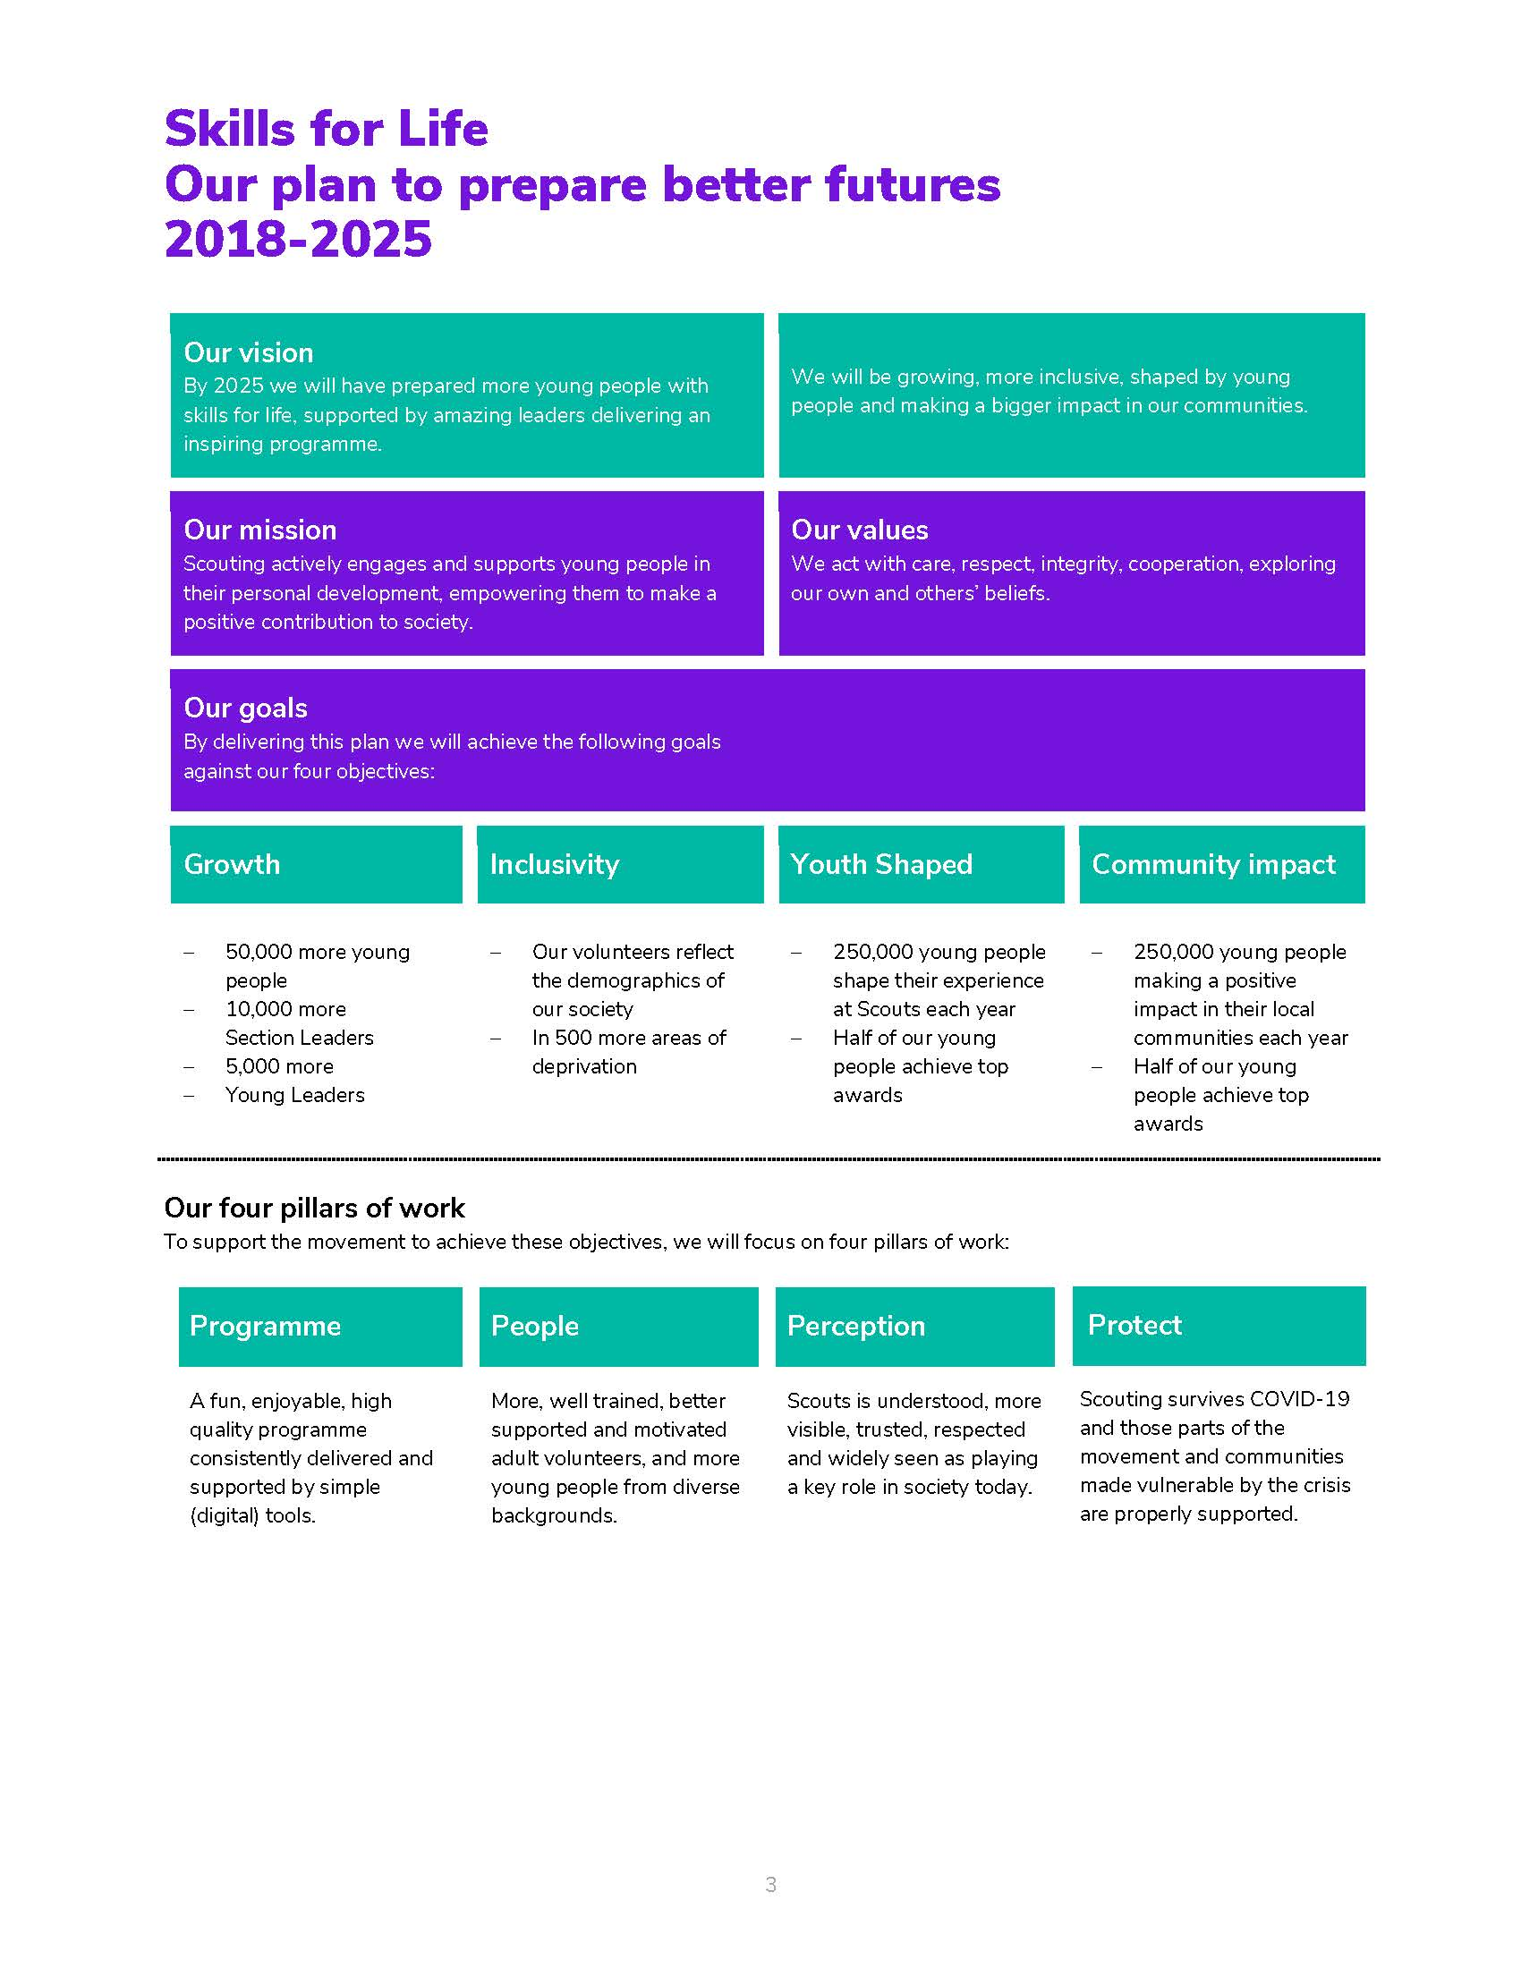
Our movement achieves remarkable things. We have continued to grow for 13 consecutive years. Our previous plan, ‘Scouting for All’, inspired new Groups and sections to start in an additional 834 areas of deprivation since 2013. We now help over 462,000 young people aged 6-18 (including 102,000 girls) get the best possible start in life. Our social action campaign, A Million Hands, has enabled over 200,000 young people to make a positive contribution in their local communities.
Now we want to go further. Skills for Life is a strategy that supports and empowers our volunteers who are the people that make Scouts a reality. It’s a strategy to bring communities together and contribute towards a better society. But most of all, it’s a strategy for young people. They deserve the best skills, the best support, and the best possible futures.

‘I believe that Scouts empowers young people. It gives them skills to achieve the remarkable, and opportunities to develop a deeper understanding of the rapidly changing world.’ Tim Kidd, UK Chief Commissioner

The Scouts Structure
The UK headquarters of the Scouts is based at Gilwell Park, Chingford, London, and is operationally divided into four directorates
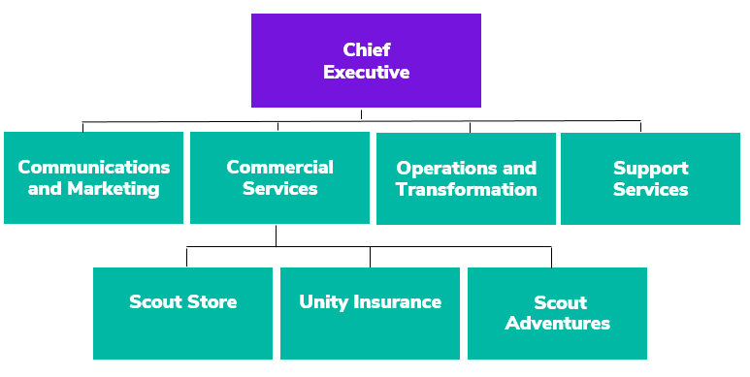

Team Structure Chart

Job Description – Product Manager (CRM)

Responsible to: Digital Delivery Manager

Department: Transformation Team

Base Location: Gilwell Park, Chingford, London (with remote working)

Term: Fixed term contract until end March 2023

Salary: £43, 064 including Outer London Weighting, Band G Level 3

Hours: 35 hours per week

Line Management Responsibility: N/A

Core Purpose

It’s an exciting time at The Scouts. Our digital transformation programme is an ambitious part of our Skills for Life strategy which aims to enable Scouts to become a digital first organisation.

We aim to transform the Scouting experience with digital tools and services for our volunteers, staff and young people which are: Easy, Enlightening, Enabling, Engaging, Enjoyable and Efficient.

Our digital principles underline all our work:

- We put people at the heart of everything we do.
- We are bold and open to change.
- We create digital first, responsive and accessible services.
- We use data and insight to drive our decisions.
- We measure, test and learn.
- We engage, collaborate and partner.
- We provide a safe and secure service.
- Our systems are flexible, sustainable and interoperable.

As a Product Manager your key purpose is to manage the development of our membership systems, working with the Delivery Manager and key teams within the organisation. Spending time listening to users, researching, understanding and communicating the product vision and then identify requirements, translate into user stories and communicate these for implementation.

In this role you will have the opportunity to develop the product roadmap, prioritisation and facilitate the delivery of the features to ensure they are released on time and are of a high quality. You will work with both internal teams, and external development partners.

This is a unique opportunity to bring your skills, experience and passion for enabling change to a growing and prestigious organisation. The digital transformation you help to deliver will support nearly half a million young people every week as they gain skills for life through Scouts.

Key Accountabilities
- Create and agree the product vision, objectives and roadmap for agreed products with key stakeholders
- Translate product vision into clearly documented user stories and acceptance criteria
- Develop, manage and monitor objectives and key results (OKRs) and key performance indicators (KPIs) for agreed products
- Support colleagues and stakeholders to produce user and organisation requirements and functional specifications
- Lead the build, test, training and deployment processes, making sure that the organisation requirements are delivered and the solution will be fit for purpose
- Facilitate the prioritisation of user stories based on delivering optimum benefit to the organisation and our members
- Facilitate and run workshops, build strong relationships and inspire confidence through your ability to understand the business, its problems and its aspirations
- Develop clear requirement specifications, ensuring that all business and systems needs are identified clearly and unambiguously, with detailed consideration for all project and technical dependencies and risks
- Carry out data analysis by identifying sources, gap analysis and requirements for migration and integration to existing systems
- Manage internal technical team members and digital partners to ensure user requirements are successfully translated into technical requirements
- Manage estimation of timescales, resources and planning to successfully deliver a project
- Work with other members of the team to provide peer quality assurance of all output
- Champion and support others to use product management methodology and techniques

Person Specification

Experience

- A track record of working on digital products with demonstrable experience of working on a variety of different CRM, tech or digital delivery projects
- Experience working with stakeholders and business users to elicit, capture, analyse, refine, communicate and document their requirements
- Experience of working with a recognised Agile or Iterative development methodology (e.g. Scrum, DSDM)
- Experience of a variety of requirements elicitation techniques, (e.g. interviews, questionnaires, user observation, workshops etc.)
- Experience of analysis of both functional and non-functional requirements
- Experience of the full project lifecycle and a good understanding of project roles and activities (technical and non-technical) required for successful delivery
- Experience of Agile documentation including Backlogs, Customer Journeys, Use Cases, User Stories, Acceptance Criteria etc.
- Experience of facilitating Agile ceremonies such as sprint planning, stand ups and retrospectives
- Experience of using data and insights to inform decision making
- Experience of working with wide range of stakeholder audiences

Desireable:
- Exposure to digital systems such as CRM, CMS, Mobile Apps and Social Media

Skills, Abilities & Knowledge
- Excellent understanding of product management principles, lean product development and agile practices.
- Excellent communication skills, with the ability to talk and present to a range of audiences, acting as a translator between parties in your field of expertise
- Able to take an informed, evidence-based approach
- A thorough understanding of current and emergent digital and technological landscape and how it will enable us to meet and exceed our strategic aims
- Excellent organisational, verbal and written communication skills
- Ability to deliver quality work in a fast-paced environment, with the ability to balance emerging & tight timelines
- Capable of prioritising and managing own workload
- Quality focus and attention to detail

Desirable

- Up-to-date knowledge of the latest trends, best practices and digital technologies
- Able to use data and insights tools (E.g. Google Analytics and Hot Jar)

Values & Personal Qualities
- A passion for creating solutions with outcomes that meet our users’ needs
- A positive attitude to change, with the resilience and flexibility that is needed to deliver transformation
- Ability to create passion and drive momentum in others
- Ability to balance strategic needs with the need to get things done
- Emotional maturity and awareness to be able to flex your communication style and listening skills to adapt to your audience and to enable you to build strong relationships
- An understanding and commitment to promote equal opportunities, safeguarding and diversity

Education & Qualifications
- Product Management training/qualification (Desirable)
- Agile, SCRUM or SAFe project management training /qualification (Desirable)
Benefits
We’ve got some great benefits
Holiday Entitlement: On top of your generous 25 days annual leave we give you up to three extra days off between Christmas and New Year. And that’s not all, holiday goes up to 28 days after 2 years’ service and 32 days after 5 years’ service (pro rata for part time staff)

Looking after your health and well-being
Simply Health scheme: Optical, dental and many more appointments covered, as well as great gym and family days out discounts.

Sickness absence: Once you’re three months in, we have generous sickness pay, above the statutory.
Wellbeing walks: Scheduled once a month at Gilwell Park, this a great chance to take an hour out of work to walk in the beautiful countryside with colleagues, taking in the fresh air.

Looking after your future

Pension Scheme: We look after your future. You will have been automatically enrolled into The Scout Association’s Group Personal Pension Plan, contributing 3% of your qualifying earnings. The Scouts will contribute double at 6% of your qualifying earnings on auto enrolment. You can increase your contribution at any point and we will double your contribution up to a maximum of 10% of your gross salary.

Looking after your family: Your loved ones will receive four times the basic salary if you pass away while employed by us.

Getting to and from work

Car parking: Parking is free at all our sites.

Minibus Service: When working at Gilwell Park, a minibus can collect you at various times from Chingford Station and drop you back at various times.

We are proud to be a family friendly employer

Personal Days: Up to four personal days paid leave a year.

Maternity/Paternity Leave: We pay maternity leave above the statutory minimum requirement.
Start and ﬁnish time: Employees can apply for some ﬂexibility on their start and ﬁnish times of work.

Making your money go that little bit further

Scout Store purchases: You can buy Scout Store merchandise with a discount of 25% on certain items.
Online beneﬁts portal: Our online beneﬁts portal allows you to tailor make your own beneﬁts package.

Developing yourself and others

Study and volunteer leave: Special leave includes paid leave for volunteering and study leave.

How to apply

Before making an application please ensure that you have read the Recruitment and Selection policy:
https://scouts.org.uk/media/1009429/Recruitment-and-Selection-Policy.pdf

You can read more about working at Scouts here: https://scouts.org.uk/about-us/jobs/working-at-the-scouts/
We would be grateful if you would also complete the Recruitment Monitoring questions on the Application Form. Our Equal Opportunities policy can be found here: https://www.scouts.org.uk/por/2-key-policies/equal-opportunities-policy/
The closing date for applications is 6th May 2021
The interviews will be held on 10th May 2021 but you may be asked to take part in an informal discussion before this.
If you would to discuss the role in more detail, please contact Recruitment@Scouts.org.uk

To submit an application, please use this Smartsheet Link:
https://app.smartsheet.com/b/form/551b902b089044f3acb28799c2821d97

