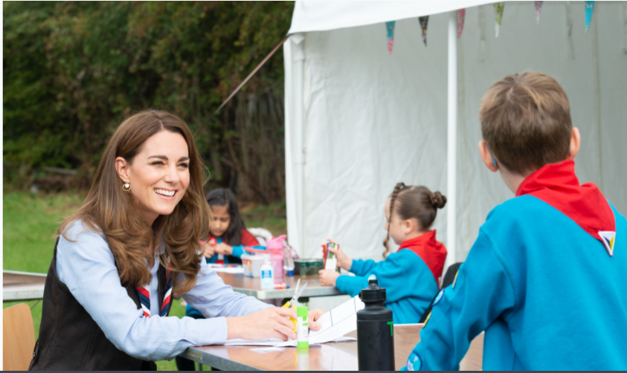

Vetting and Safeguarding Collaboration Lead
(Pears Volunteer Recruitment and Joining Project with Girlguiding)

Applicant Information Pack

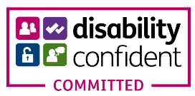

About us 3
Our strategic plan 4
Our structure 5
Job Description 6
Benefits 7
How to apply 8

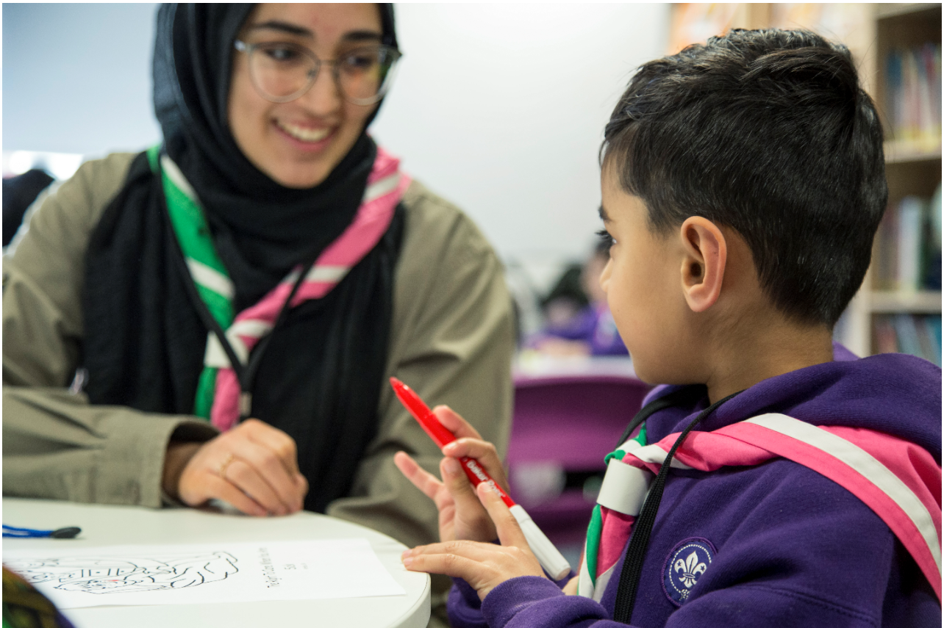
About us

We're Scouts and everyone's welcome here. All genders, races and backgrounds. Every week we give almost half a million people aged 6-25 the skills they need for school, college, university, the job interview, the important speech, the tricky challenge and the big dreams: the skills they need for life.
At a time when communities are becoming more divided, we bring people together. We encourage our young people to do more, learn more and be more. We’re a worldwide movement, creating stronger communities and inspiring positive futures. We welcome talent from all backgrounds and your contribution to help even more young people succeed in life.
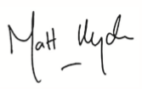
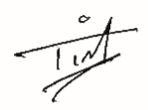

Tim Kidd, UK Chief Commissioner Matt Hyde, Chief Executive

Our Values

Integrity Respect Care
Belief Cooperation
Our strategic plan
By 2025 we will have prepared more young people with skills for life, supported by amazing leaders who deliver an inspiring programme. We will be growing, more inclusive, shaped by young people and making a bigger impact in our communities.

Society is changing. In often fragmented communities, the pressures and expectations on young people are increasing. The future is uncertain. Scouts has never been so important in helping young people prepare for the future, developing the skills they need to succeed in a changing world. Each week almost half a million young people enjoy fun, friendship and outdoor adventure. They develop a sense of optimism and strong values as well as the leadership and team working skills that are more valuable today than ever.
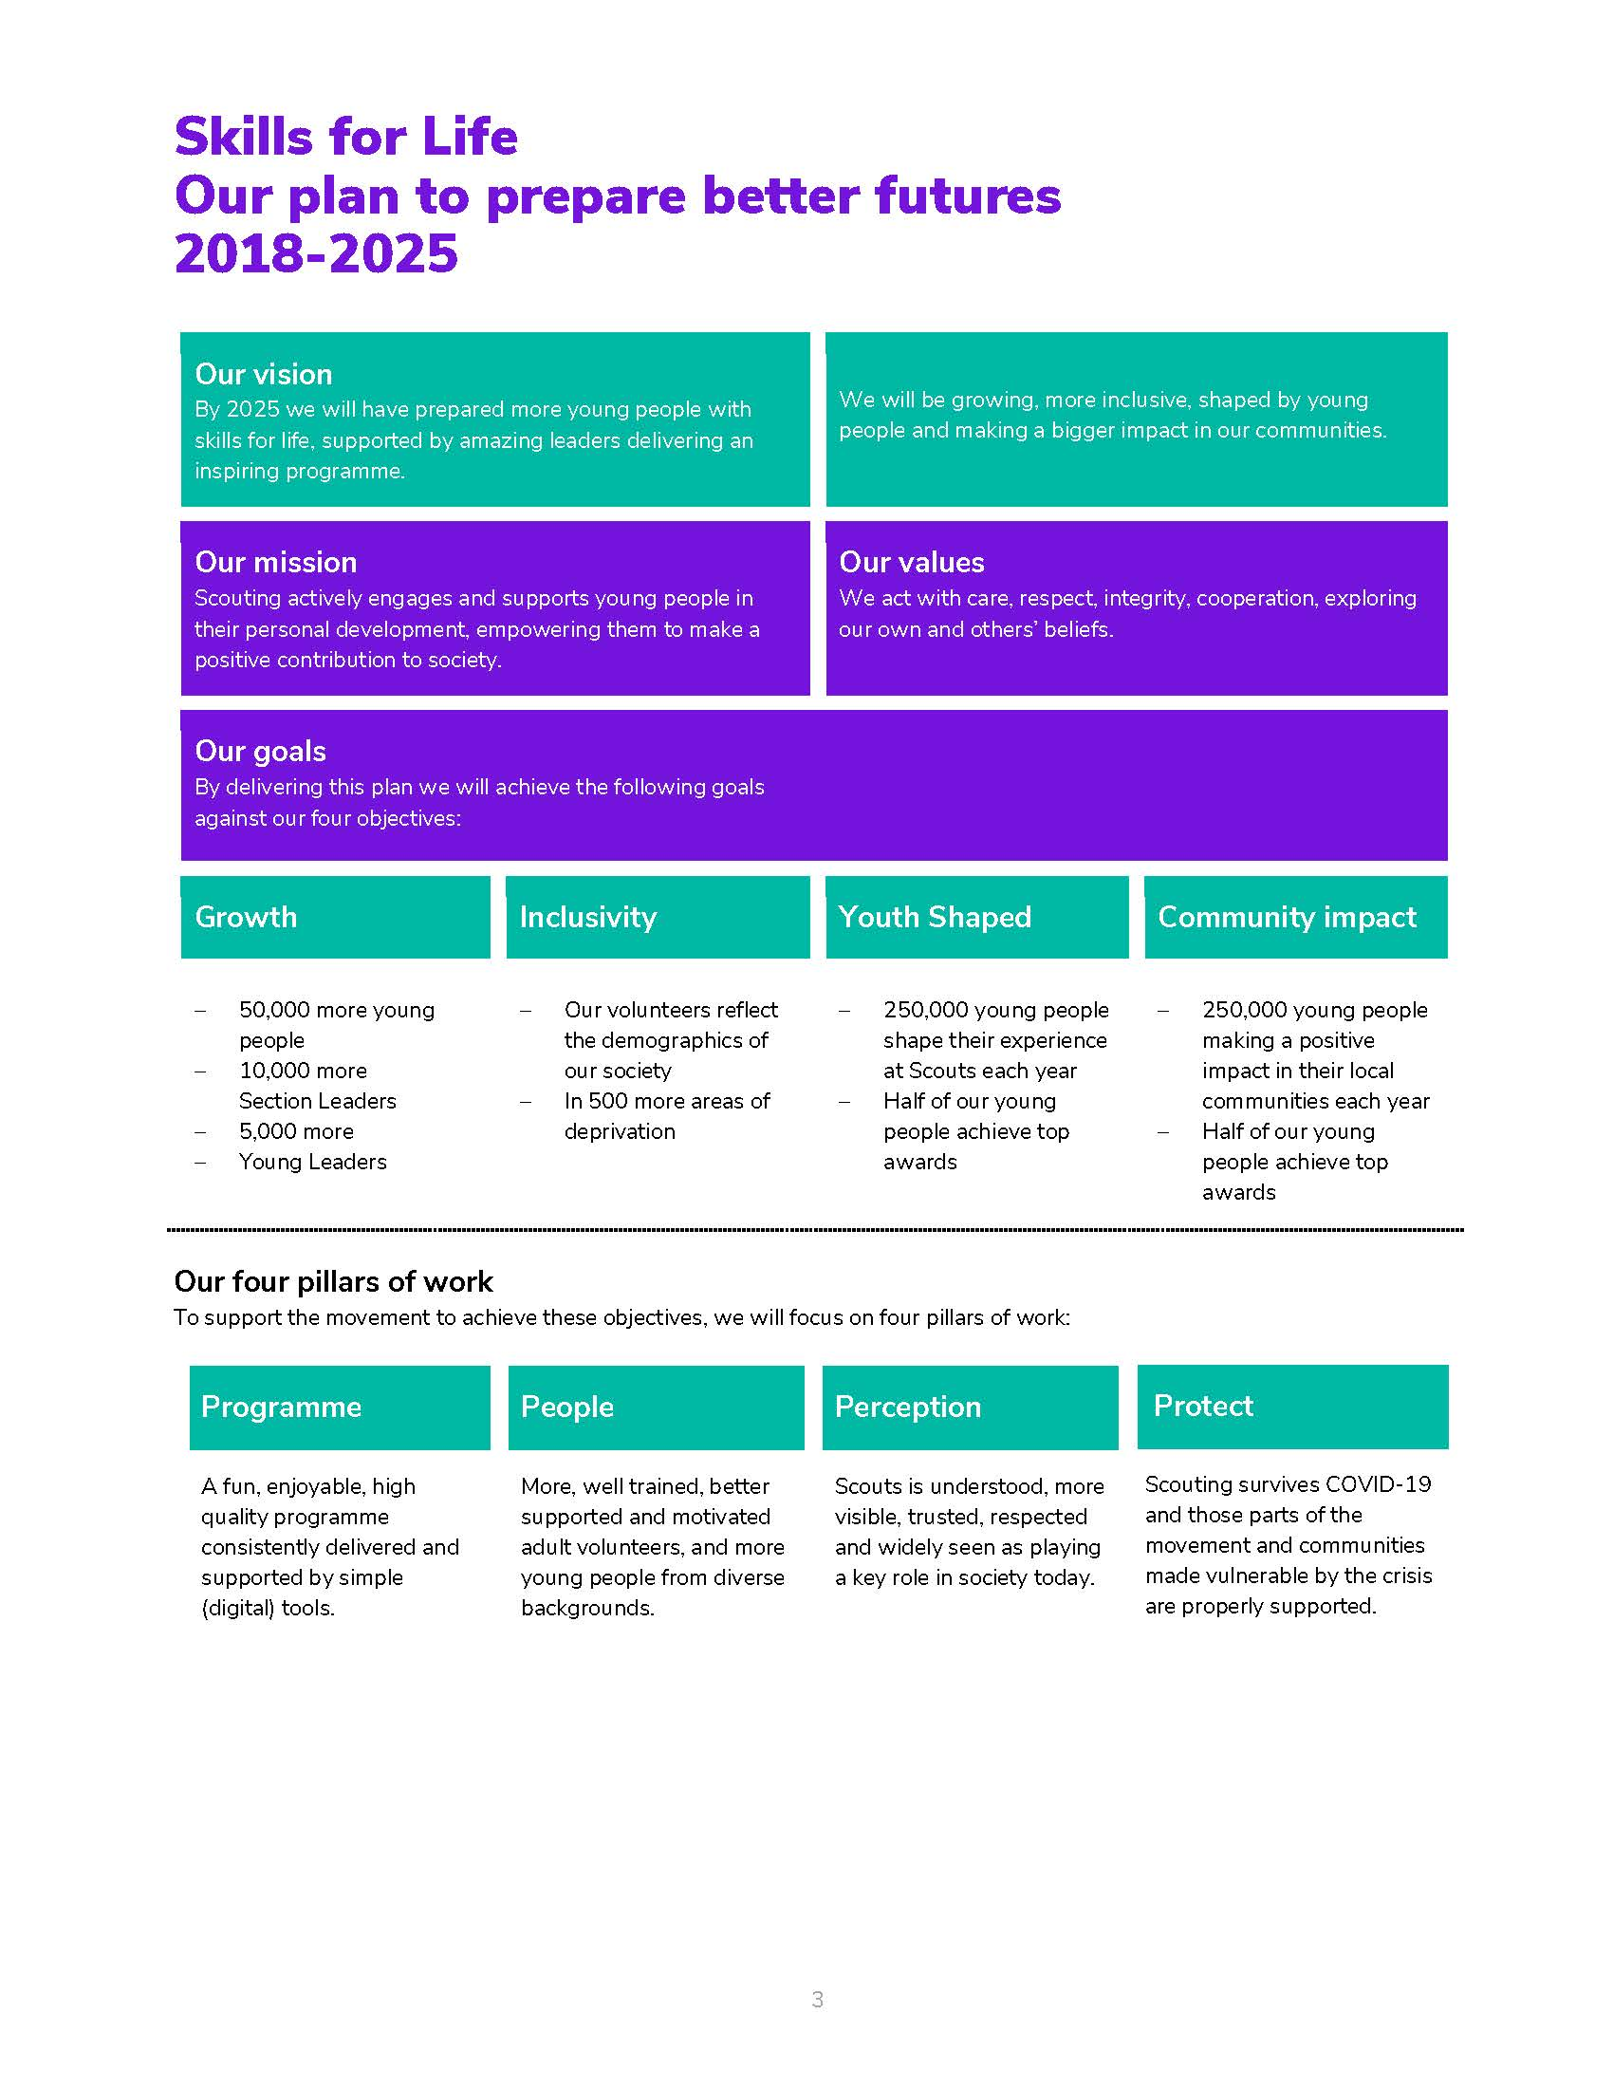
Our movement achieves remarkable things. We have continued to grow for 13 consecutive years. Our previous plan, ‘Scouting for All’, inspired new Groups and sections to start in an additional 834 areas of deprivation since 2013. We now help over 462,000 young people aged 6-18 (including 102,000 girls) get the best possible start in life. Our social action campaign, A Million Hands, has enabled over 200,000 young people to make a positive contribution in their local communities.
Now we want to go further. Skills for Life is a strategy that supports and empowers our volunteers who are the people that make Scouts a reality. It’s a strategy to bring communities together and contribute towards a better society. But most of all, it’s a strategy for young people. They deserve the best skills, the best support, and the best possible futures.

‘I believe that Scouts empowers young people. It gives them skills to achieve the remarkable, and opportunities to develop a deeper understanding of the rapidly changing world.’ Tim Kidd, UK Chief Commissioner

The Scouts Structure
The UK headquarters of the Scouts is based at Gilwell Park, Chingford, London, and is operationally divided into four directorates
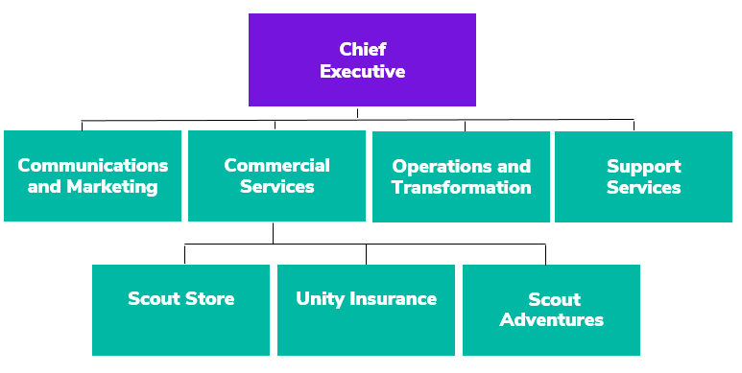

Team Structure Chart
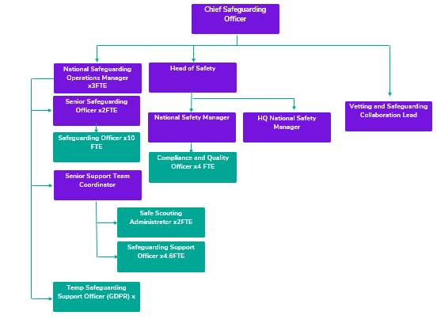
Job Description

Responsible to: Chief Safeguarding Officer

Department: Operations & Transformation

Base Location: Gilwell Park, Chingford London (Scouts).
Please note this role is contractually employed by Scouts but works collaboratively across both Scouts and Girlguiding. Therefore, the role will also be expected to spend time at the Girlguiding Headquarters at Buckingham Palace Rd, London.
Working from home can be considered for this role, but some travel to both headquarters sites will be required.

Term: Fixed term: Starting July 2021- December 2022.

Salary: £25,838 per annum which is pro rata of £43,064 per annum (inclusive of Outer London Weighting), representing Band G, Level 3

Hours: 21 hours per week

Line Management Responsibility: n/a

Core Purpose

It’s an exciting time at both Scouts and Girlguiding. We are working together to make the experience for volunteers more inclusive, accessible and welcoming. We want all our volunteers to continue to feel valued, starting from the very first moment they start the recruitment and joining process. This role will greatly contribute to an exciting collaborative project between the organisations, funded by Pears Foundation, which aims to:

- Improve the volunteer experience for new people joining our organisations, as well as those who already volunteer but are changing role.
- Make the recruitment and joining process easier and more inclusive, removing barriers for accessibility and supporting people from underrepresented backgrounds to volunteer.
- Remove some of the administrative burden for current volunteers, making the process more intuitive and flexible.
- Meet modern expectations around volunteering and better suit people’s lifestyles- matching people’s skills sets and needs with the needs of our units and groups.
- Give people options to more easily support both charities and remove barriers for those who volunteer across both.
To help us achieve our shared aims, we are looking for someone with a strong understanding and experience of vetting and safeguarding practices involved with recruiting and onboarding volunteers.

Through aligning our already strong and robust vetting and safeguarding processes, we can make it easier for volunteers to support both organisations, making cross organisational working easier and more effective for future meetings and events.

The role will specifically lead on developing these processes, working with volunteers and staff from across the separate organisations. The role will ensure processes are more aligned, easy to navigate and inclusive- whilst keeping everyone safe.

The right individual for this role will have a passion for collaborative working, sharing best practice and finding practical solutions.

Key Accountabilities
- Developing and delivering solutions for already identified areas of the recruitment and onboarding process (within the vetting and safeguarding scope) that can be aligned.

- Working with current and potential volunteers, as well as internal teams to ensure the solutions meet the needs of the end user- volunteers, and that the solutions developed are fit for purpose- they make things easier and remove barriers, whilst continuing to ensure safe Scouting and Guiding.

- Leading further exploration around areas of the process that need further consultation.

- Developing scenario statements with both teams to ensure that different safeguarding situations have been captured and working with both organisations to identify solutions together where possible.

- Working with colleagues with equality, diversity and inclusion expertise to identify where we can further support people from underrepresented or marginalised communities to volunteer, whilst ensuring support is within the parameters of the processes to keep everyone safe.

- Working with the project team to develop the content that supports volunteers through the vetting and disclosure process.

- Developing recommendations and leading these through the governance boards of both organisations, presenting key information to stakeholders when required.

- Working with key stakeholders in both organisations to make approved changes to the vetting and safeguarding elements of the volunteer journey.

- Engaging in organisational and sector discussions on passporting and shared volunteering.

- Working with colleagues in digital transformation teams to ensure digital products continue to keep people safe and communicating requirements from a safeguarding and vetting perspective.

Person Specification

Experience
- Experience of working in a safeguarding and vetting environment in a complex organisation.
- Understanding of policies, procedures and best practice when recruiting and onboarding.
- Experience of collaborating across multiple teams and organisations, balancing the needs of multiple stakeholders.
- Experience of working on digital projects or with digital teams to develop solutions that keep people safe.
- Experience of delivering organisational changes to processes and policies and an understanding of how to implement change and take people on the journey.
- Experience of presenting information to senior stakeholders and boards.

Skills, Abilities & Knowledge
- Good communication and interpersonal skills to enable successful influencing, listening and negotiating with others.
- Highly analytical and able to develop practical solutions to achieve agreed objectives and to help make clear, informed and timely decisions.
- Excellent planning and organisational skills with the ability to ensure effective prioritisation, balancing the needs of a range of stakeholders.
- Knowledge of the UK disclosures processes- Disclosure Barring Service, Protecting Vulnerable Groups and Access Northern Ireland.
- Ability to co-create solutions with a wide range of stakeholders and develop and sustain productive stakeholder relationships internally and externally.
- Thrives working and leading in a fast pace environment across multiple teams, whilst also able to work autonomously within the given framework.
- Creative and innovative and can react to emerging thinking and adapt accordingly.

Values & Personal Qualities
- Committed to living the values of both the Scouts and Girlguiding.
- Commitment to adult volunteers and young people, understanding their needs and a passion for supporting them to be the best and stay safe.
- Open, confident and collaborative with the willingness to challenge constructively and to work effectively with a wide range of stakeholders.
- Able to maintain an up-to-date knowledge and technical competency.
- Positive and proactive in overcoming challenges and barriers.

Other Essential Criteria
This role will require regular evening and weekend working. The role holder must be willing to be flexible and available to work with volunteer teams as needed.

Benefits
We’ve got some great benefits
Holiday Entitlement: On top of your generous 25 days holiday we give you up to three extra days off between Christmas and New Year. And that’s not all, holiday goes up to 28 days after 2 years’ service and 32 days after 5 years’ service. This is pro rata for part time staff.

Looking after your health and well-being
Simply Health scheme: Optical, dental and many more appointments covered, as well as great gym and family days out discounts.

Sickness absence: Once you’re three months in, we have generous sickness pay, above the statutory.
Wellbeing walks: Scheduled once a month at Gilwell Park, this a great chance to take an hour out of work to walk in the beautiful countryside with colleagues, taking in the fresh air.

Looking after your future

Generous Pension Scheme: We look after your future. You will have been automatically enrolled into The Scout Association’s Group Personal Pension Plan, contributing 3% of your qualifying earnings. The Scouts will contribute double at 6% of your qualifying earnings on auto enrolment. You can increase your contribution at any point and we will double your contribution up to a maximum of 10% of your gross salary.

Looking after your family: Your loved ones will receive four times the basic salary if you pass away while employed by us.

Getting to and from work

Car parking: Parking is free at all our sites.

Minibus Service: When working at Gilwell Park, a minibus can collect you at various times from Chingford Station and drop you back at various times.

We are proud to be a family friendly employer

Personal Days: Up to four personal days paid leave a year.

Maternity/Paternity Leave: We pay maternity leave above the statutory minimum requirement.
Start and ﬁnish time: Employees can apply for some ﬂexibility on their start and ﬁnish times of work.

Making your money go that little bit further

Scout Store purchases: You can buy Scout Store merchandise with a discount of 25% on certain items.
Online beneﬁts portal: Our online beneﬁts portal allows you to tailor make your own beneﬁts package.

Developing yourself and others

Study and volunteer leave: Special leave includes paid leave for volunteering and study leave.

How to apply

Before making an application please ensure that you have read the Recruitment and Selection policy:
https://scouts.org.uk/media/1009429/Recruitment-and-Selection-Policy.pdf

You can read more about working at Scouts here:
https://scouts.org.uk/about-us/jobs/working-at-the-scouts/
We would be grateful if you would also complete the Recruitment Monitoring questions on the Application Form. Our Equal Opportunities policy can be found here:
https://www.scouts.org.uk/por/2-key-policies/equal-opportunities-policy/
The closing date for applications for this position is Wednesday 12th May 2021, with interviews taking place on Thursday 27th May. This will involve a short presentation

If you would to discuss the role in more detail, please contact Recruitment@Scouts.org.uk

To submit an application, please use this Smartsheet Link: https://app.smartsheet.com/b/form/cff12763e0de4091888a79e8db3ccf43

