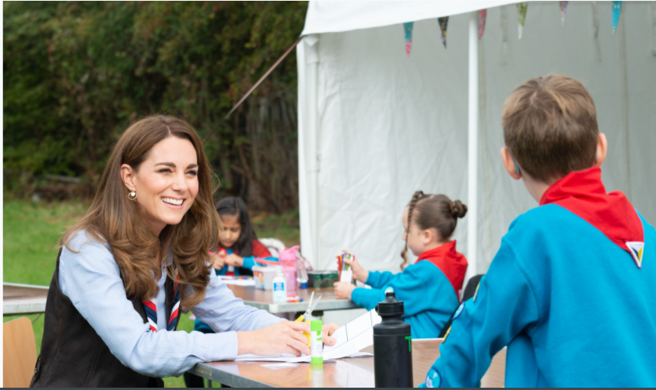

Volunteer Journey Executive (Collaboration)

Pears Volunteer Recruitment and Joining Project- Scouts and Girlguiding Collaboration

Applicant Information Pack

About us 3
Our strategic plan 4
Our structure 5
Job Description 6
Benefits 7
How to apply 8

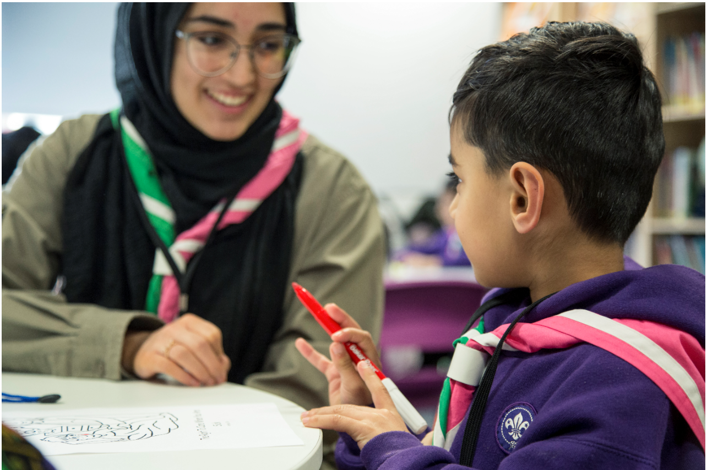
About us

We're Scouts and everyone's welcome here. All genders, races and backgrounds. Every week we give almost half a million people aged 6-25 the skills they need for school, college, university, the job interview, the important speech, the tricky challenge and the big dreams: the skills they need for life.
At a time when communities are becoming more divided, we bring people together. We encourage our young people to do more, learn more and be more. We’re a worldwide movement, creating stronger communities and inspiring positive futures. We welcome talent from all backgrounds and your contribution to help even more young people succeed in life.
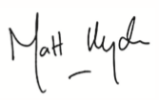
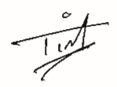

Tim Kidd, UK Chief Commissioner Matt Hyde, Chief Executive

Our Values

Integrity Respect Care
Belief Cooperation
Our strategic plan
By 2025 we will have prepared more young people with skills for life, supported by amazing leaders who deliver an inspiring programme. We will be growing, more inclusive, shaped by young people and making a bigger impact in our communities.

Society is changing. In often fragmented communities, the pressures and expectations on young people are increasing. The future is uncertain. Scouts has never been so important in helping young people prepare for the future, developing the skills they need to succeed in a changing world. Each week almost half a million young people enjoy fun, friendship and outdoor adventure. They develop a sense of optimism and strong values as well as the leadership and team working skills that are more valuable today than ever.
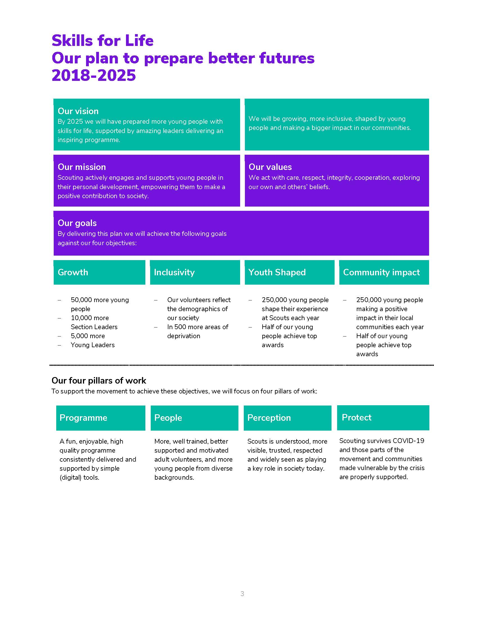
Our movement achieves remarkable things. We have continued to grow for 13 consecutive years. Our previous plan, ‘Scouting for All’, inspired new Groups and sections to start in an additional 834 areas of deprivation since 2013. We now help over 462,000 young people aged 6-18 (including 102,000 girls) get the best possible start in life. Our social action campaign, A Million Hands, has enabled over 200,000 young people to make a positive contribution in their local communities.
Now we want to go further. Skills for Life is a strategy that supports and empowers our volunteers who are the people that make Scouts a reality. It’s a strategy to bring communities together and contribute towards a better society. But most of all, it’s a strategy for young people. They deserve the best skills, the best support, and the best possible futures.

‘I believe that Scouts empowers young people. It gives them skills to achieve the remarkable, and opportunities to develop a deeper understanding of the rapidly changing world.’ Tim Kidd, UK Chief Commissioner

The Scouts Structure
The UK headquarters of the Scouts is based at Gilwell Park, Chingford, London, and is operationally divided into four directorates
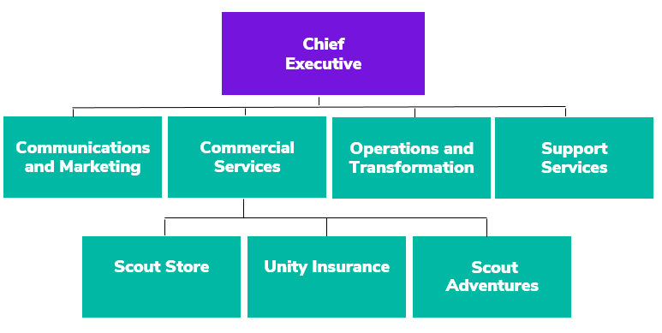

Team Structure Chart
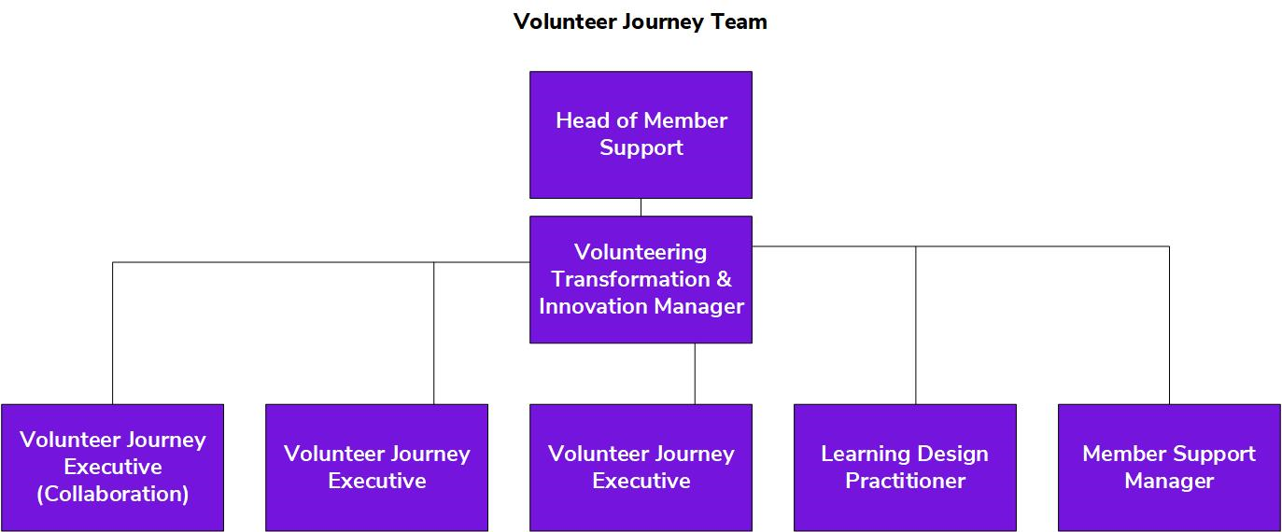

Job Description

Responsible to: Volunteering Transformation Manager

Department: Operations & Transformation

Base Location: Gilwell Park, Chingford, London with UK travel
(flexible working options can be discussed.)
As the role works in collaboration with Girlguiding, there is an expectation to attend meetings at Girlguiding Headquarters as needed.

Term: Two-year fixed term contract

Salary: £35,354 per annum (inclusive of Outer London Weighting),
Band F, Level 3

Hours: 35 hours per week

Line Management Responsibility: n/a

Core Purpose

The volunteer journey describes an adult volunteer’s path through the Scouts. It goes from the moment they are first recruited and welcomed into the movement, through appointment and induction and into training, recognition and review.

We want to make this journey easier and more rewarding for all volunteers. As part of the Skills for Life strategy we are developing and supporting amazing section leaders by:

- Making sure that section leader teams have the right support for the future, by ensuring we have the right adult roles responsible for the right things
- Transforming the adult recruitment and joining process, making sure it is inclusive and welcoming
- Simplifying training, focusing on developing and supporting amazing section leaders
- Creating a positive and rewarding volunteer experience for new and existing volunteers
- Helping equip section leader teams with the practical skills and knowledge needed to deliver a challenging and adventurous programme

To do this we are fundamentally reviewing our whole volunteer journey, including how we attract, recruit, appoint, train, review, recognise and refresh all of our adult roles. We have started from scratch to design a process, based on user research, that provides a great experience and makes the best use of digital technology.

This role will focus primarily on the recruitment and joining part of the volunteer journey, as part of a collaboration project with Girlguiding and funded by Pears Foundation.

We are working together with Girlguiding to make the joining experience for volunteers more inclusive, accessible and welcoming. We want all our volunteers to feel valued, starting from the very first moment they start the process. Through creating new processes and resources, including the implementation of a new digital tool, the project will provide a vehicle for wider cultural change.

The project aims to:
- Improve the volunteer experience for new people joining our organisations, as well as those who already volunteer but are changing role.
- Make the recruitment and joining process easier and more inclusive, removing barriers for accessibility and supporting people from underrepresented backgrounds to volunteer.
- Remove some of the administrative burden for current volunteers who undertake the recruitment, making the process more intuitive and flexible to administer.
- Meet modern expectations around volunteering and better suit people’s lifestyles- matching people’s skill sets and needs with the needs of units and groups.
- Give people options to more easily support both charities and to remove barriers for those who volunteer across both.
The role will work closely with volunteers and staff colleagues across the organisations to design and develop processes and support resources (both digital and offline).

Key Accountabilities
- Working as part of the Pears Volunteer Recruitment and Joining Product Team, lead and develop the processes, systems, resources, and training materials to support work on this part of the volunteer journey.
- Organise and support user engagement including information collection, design co-creation and testing and piloting with our volunteer network, community of interest and new potential volunteers.

- Working closely with the wider Volunteer Journey team to ensure that the journey is joined up, feeding into other relevant aspects of the journey and communicating learning and dependencies.
- Liaise with staff teams, across the organisations in particular Communications, Digital Transformation and Safeguarding to support and deliver the project.
- Work closely with staff and volunteer colleagues to manage the transition of new products/processes/systems as they become live and support their role out.
- Act autonomously to deliver on stretching objectives related to The Volunteer Journey design and development and maintain a complete understanding of the organisation’s strategy and theory of change.
- Work with partners from the voluntary sector and use best practise to influence the process design for the volunteer journey.

Person Specification

Experience

- Experience of developing volunteering processes and support resources for volunteers or for a similar organisation. In particular: design of volunteer roles or offers, attraction, induction, and training/support resources/solutions for volunteers and volunteer managers ensuring user needs are at the heart of the design
- Knowledge and understanding of current volunteering trends, challenges and solutions
- Experience of supporting the design and delivery of activities related to the Volunteer Journey, demonstrating innovative thinking and the creation of new solutions
- Experience of process development and measurement including undertaking user research and using data and insights to inform decision making
- Experience of working with volunteers or a volunteering organisation
- Experience of leading and delivering complex change projects with multiple stakeholders
- Experience of matrix management and collaborating across teams and organiations

Skills, Abilities & Knowledge
- Experience of volunteering development with the ability to co-create simple but effective processes and resources to support the recruitment and joining of volunteers. A collaborator who can work across organisations with both staff and volunteer teams to achieve goals and get things done effectively.
- Ability to co-create and implement effective plans and develop practical solutions to achieve agreed objectives and to help make clear, informed and timely decisions
- Good communication and interpersonal skills to enable successful influencing, listening and negotiating with others, ideally in a volunteering organisation environment
- Good planning and organisational skills with the ability to manage and deliver a diverse workload , whilst ensuring effective prioritisation and balancing of the needs of a range of stakeholders
- Ability to co-create solutions with a wide range of stakeholders (including remotely/digitally) and develop and sustain productive stakeholder relationships internally and externally
- Proactive in approach to project design and delivery (with strong project management skills) and able to work autonomously within the given framework
- Thrives working in a fast pace, flexible, agile environment
- Creative and innovative and can react to emerging thinking and adapt accordingly
- Confident in using different technology and social media
- Ability to use project management methodology/systems

Values & Personal Qualities
- Committed to living the values of the organisation
- A strong sense of accountability and empowerment in a values based culture
- Commitment to adult volunteers and young people, understanding their needs and a passion for supporting them to be the best
- Open, confident and collaborative with the willingness to challenge constructively and to receive challenge
- Able to maintain an up-to-date knowledge and technical competency
- Positive and proactive in overcoming challenges and barriers
- Commitment to working collaboratively across organisations, sharing learning and solving challenges together in partnership.

Other Essential Criteria
This role will require regular evening and weekend working. The role holder must be willing to be flexible and available to work with volunteer teams as needed.

Benefits
We’ve got some great benefits
Holiday Entitlement: On top of your generous 25 days holiday we give you up to three extra days off between Christmas and New Year. And that’s not all, holiday goes up to 28 days after 2 years’ service and 32 days after 5 years’ service.

Looking after your health and well-being
Simply Health scheme: Optical, dental and many more appointments covered, as well as great gym and family days out discounts.

Sickness absence: Once you’re three months in, we have generous sickness pay, above the statutory.
Wellbeing walks: Scheduled once a month at Gilwell Park, this a great chance to take an hour out of work to walk in the beautiful countryside with colleagues, taking in the fresh air.

Looking after your future

Pension Scheme: We look after your future. You will have been automatically enrolled into The Scout Association’s Group Personal Pension Plan, contributing 3% of your qualifying earnings. The Scouts will contribute double at 6% of your qualifying earnings on auto enrolment. You can increase your contribution at any point and we will double your contribution up to a maximum of 10% of your gross salary.

Looking after your family: Your loved ones will receive four times the basic salary if you pass away while employed by us.

Getting to and from work

Car parking: Parking is free at all our sites.

Minibus Service: When working at Gilwell Park, a minibus can collect you at various times from Chingford Station and drop you back at various times.

We are proud to be a family friendly employer

Personal Days: Up to four personal days paid leave a year.

Maternity/Paternity Leave: We pay maternity leave above the statutory minimum requirement.
Start and ﬁnish time: Employees can apply for some ﬂexibility on their start and ﬁnish times of work.

Making your money go that little bit further

Scout Store purchases: You can buy Scout Store merchandise with a discount of 25% on certain items.
Online beneﬁts portal: Our online beneﬁts portal allows you to tailor make your own beneﬁts package.

Developing yourself and others

Study and volunteer leave: Special leave includes paid leave for volunteering and study leave.

How to apply

Before making an application please ensure that you have read the Recruitment and Selection policy:
https://scouts.org.uk/media/1009429/Recruitment-and-Selection-Policy.pdf

You can read more about working at Scouts here:
https://scouts.org.uk/about-us/jobs/working-at-the-scouts/
We would be grateful if you would also complete the Recruitment Monitoring questions on the Application Form. Our Equal Opportunities policy can be found here:
https://www.scouts.org.uk/por/2-key-policies/equal-opportunities-policy/
The closing date for applications is Wednesday 12th May.

The interviews will be held on Wednesday 19th May.

If you would to discuss the role in more detail, please contact Recruitment@Scouts.org.uk

To submit an application, please use this Smartsheet Link:
https://app.smartsheet.com/b/form/30399394ff364215be73eddd874b776c

