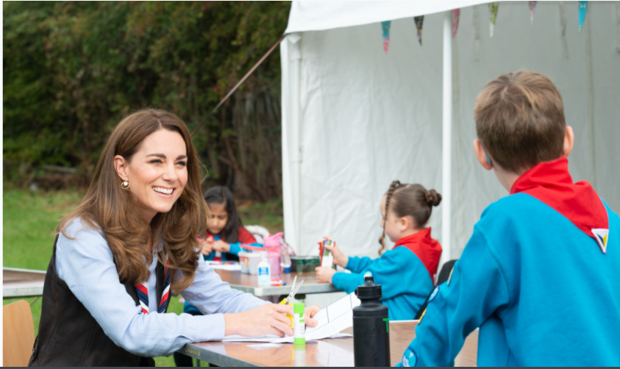

Senior Customer Service Advisor

Applicant Information Pack

About us 3
Our strategic plan 4
Our structure 5
Job Description 6
Benefits 7
How to apply 8

About us

We're Scouts and everyone's welcome here. All genders, races and backgrounds. Every week we give almost half a million people aged 6-25 the skills they need for school, college, university, the job interview, the important speech, the tricky challenge and the big dreams: the skills they need for life.
At a time when communities are becoming more divided, we bring people together. We encourage our young people to do more, learn more and be more. We’re a worldwide movement, creating stronger communities and inspiring positive futures. We welcome talent from all backgrounds and your contribution to help even more young people succeed in life.
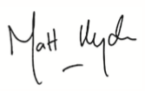
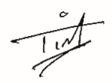

Tim Kidd, UK Chief Commissioner Matt Hyde, Chief Executive

Our Values

Integrity Respect Care
Belief Cooperation
Our strategic plan
By 2025 we will have prepared more young people with skills for life, supported by amazing leaders who deliver an inspiring programme. We will be growing, more inclusive, shaped by young people and making a bigger impact in our communities.

Society is changing. In often fragmented communities, the pressures and expectations on young people are increasing. The future is uncertain. Scouts has never been so important in helping young people prepare for the future, developing the skills they need to succeed in a changing world. Each week almost half a million young people enjoy fun, friendship and outdoor adventure. They develop a sense of optimism and strong values as well as the leadership and team working skills that are more valuable today than ever.
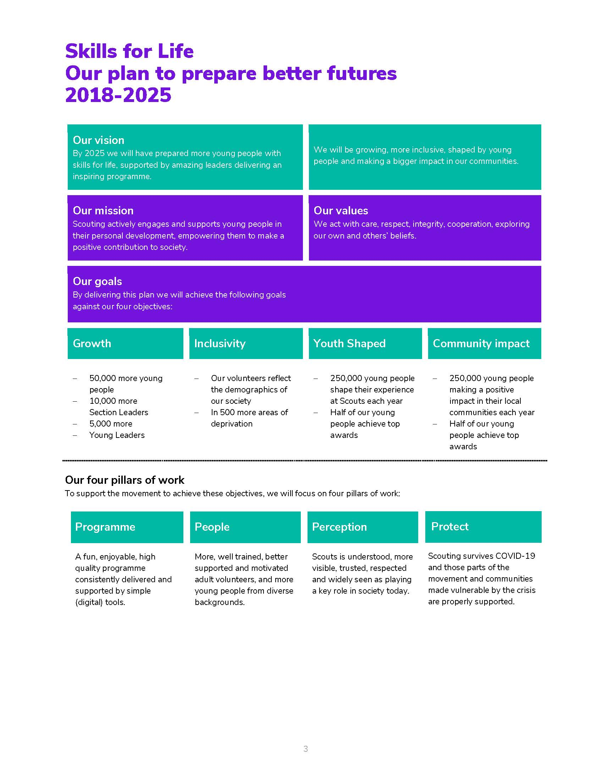
Our movement achieves remarkable things. We have continued to grow for 13 consecutive years. Our previous plan, ‘Scouting for All’, inspired new Groups and sections to start in an additional 834 areas of deprivation since 2013. We now help over 462,000 young people aged 6-18 (including 102,000 girls) get the best possible start in life. Our social action campaign, A Million Hands, has enabled over 200,000 young people to make a positive contribution in their local communities.
Now we want to go further. Skills for Life is a strategy that supports and empowers our volunteers who are the people that make Scouts a reality. It’s a strategy to bring communities together and contribute towards a better society. But most of all, it’s a strategy for young people. They deserve the best skills, the best support, and the best possible futures.

‘I believe that Scouts empowers young people. It gives them skills to achieve the remarkable, and opportunities to develop a deeper understanding of the rapidly changing world.’ Tim Kidd, UK Chief Commissioner

The Scouts Structure
The UK headquarters of the Scouts is based at Gilwell Park, Chingford, London, and is operationally divided into four directorates
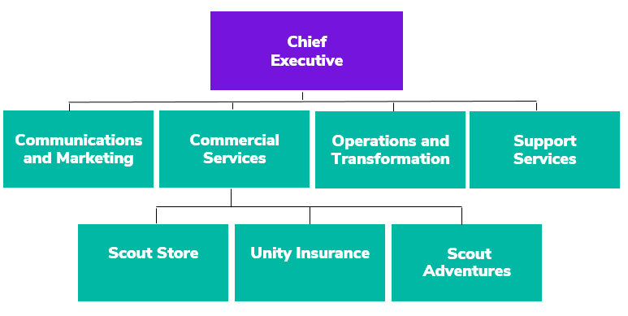

Team Structure Chart

Job Description – Senior Customer Service Advisor

Responsible to: Customer Service Manager

Department: Contact Centre

Base Location: Lancing

Term: Permanent

Salary: £24,641 Band D Level 3

Hours: 35 (May include 1-2 evening shifts per week)

Core Purpose

This role will function in the capacity of a Customer Service Advisor, with a level of seniority, having a primary responsibility of overseeing and leading the daily work of the Contact Centre team. Implementing a dynamic style of supervision to ensure the team workflows are being adapted where/when necessary, across all touch points and customer contact channels. This will require a fundamental understanding of resource management, which will be planned and reviewed regularly with the Customer Service Manager.
The position holder will be responsible for managing escalation processes and customer complaints, to provide a personal and positive outcome in the more sensitive customer scenarios.
The Senior Advisor will also be expected to periodically provide input around departmental strategy, with a focus on proposing improvements to existing processes and suggestions for new procedures. This will revolve around the strategies ‘customer’ pillar of work; to place the customer at the heart of everything we do.
Essentially this role will display role model behaviour, task prioritisation and adherence to KPI’s, driving best practice across the team. They will show elementary leadership qualities, inspiring other team members to go above and beyond to deliver excellent customer service.

Key Accountabilities
- Day to day supervision of the Contact Centre team
- Providing suggestions and proposals to the Customer Service Manager to help streamline processes, increase output and improve customer service
- Monitoring and encouraging daily adherence to the rotas and team KPI’s
- Covering all Contact Centre communication channels
- Complaints handling
- Monitoring, investigating and responding to customer reviews
- Providing evening support 1-2 times per week (ad-hoc to cover team sickness/holidays)
- Occasionally assisting other departments

Person Specification

Experience

- Experience of team supervision preferable
- Understand and apply customer services/sales solutions to support implementation of business plans and strategies
- Strong retail commercial background within customer services demonstrable evidence of proven results
- Good telephone manner, including clear speech, the ability to understand people with speech impediments and unusual accents, and excellent manners.
- Persuasiveness, with the ability to soothe unhappy customers and to persuade them to retain services or make further purchases.

Skills, Abilities & Knowledge
- The ability to communicate information clearly.
- Creative ways to solve a problem.
- The ability to carry out the job with the greatest of accuracy to avoid errors and creating unnecessary costs.
- An understanding of empathy and objection handling

Values & Personal Qualities
- Ability to Work in a Team Environment
- Ability to work under pressure
- Flexible in approach to issues and show initiative whilst doing the job.

Benefits
We’ve got some great benefits
Holiday Entitlement: On top of your generous 25 days annual leave we give you up to three extra days off between Christmas and New Year. And that’s not all, holiday goes up to 28 days after 2 years’ service and 32 days after 5 years’ service (pro rata for part time staff)

Looking after your health and well-being
Simply Health scheme: Optical, dental and many more appointments covered, as well as great gym and family days out discounts.

Sickness absence: Once you’re three months in, we have generous sickness pay, above the statutory.
Wellbeing walks: Scheduled once a month at Gilwell Park, this a great chance to take an hour out of work to walk in the beautiful countryside with colleagues, taking in the fresh air.

Looking after your future

Pension Scheme: We look after your future. You will have been automatically enrolled into The Scout Association’s Group Personal Pension Plan, contributing 3% of your qualifying earnings. The Scouts will contribute double at 6% of your qualifying earnings on auto enrolment. You can increase your contribution at any point and we will double your contribution up to a maximum of 10% of your gross salary.

Looking after your family: Your loved ones will receive four times the basic salary if you pass away while employed by us.

Getting to and from work

Car parking: Parking is free at all our sites.

Minibus Service: When working at Gilwell Park, a minibus can collect you at various times from Chingford Station and drop you back at various times.

We are proud to be a family friendly employer

Personal Days: Up to four personal days paid leave a year.

Maternity/Paternity Leave: We pay maternity leave above the statutory minimum requirement.
Start and ﬁnish time: Employees can apply for some ﬂexibility on their start and ﬁnish times of work.

Making your money go that little bit further

Scout Store purchases: You can buy Scout Store merchandise with a discount of 25% on certain items.
Online beneﬁts portal: Our online beneﬁts portal allows you to tailor make your own beneﬁts package.

Developing yourself and others

Study and volunteer leave: Special leave includes paid leave for volunteering and study leave.

How to apply

Before making an application please ensure that you have read the Recruitment and Selection policy:
https://scouts.org.uk/media/1009429/Recruitment-and-Selection-Policy.pdf

You can read more about working at Scouts here: https://scouts.org.uk/about-us/jobs/working-at-the-scouts/
We would be grateful if you would also complete the Recruitment Monitoring questions on the Application Form. Our Equal Opportunities policy can be found here: https://www.scouts.org.uk/por/2-key-policies/equal-opportunities-policy/
The closing date for applications is 12 May 2021
The interviews will be held on 18 May 2021
If you would to discuss the role in more detail, please contact Recruitment@Scouts.org.uk

To submit an application, please use this Smartsheet Link:
https://app.smartsheet.com/b/form/951833e0334a4c63954e73352ab3f469

