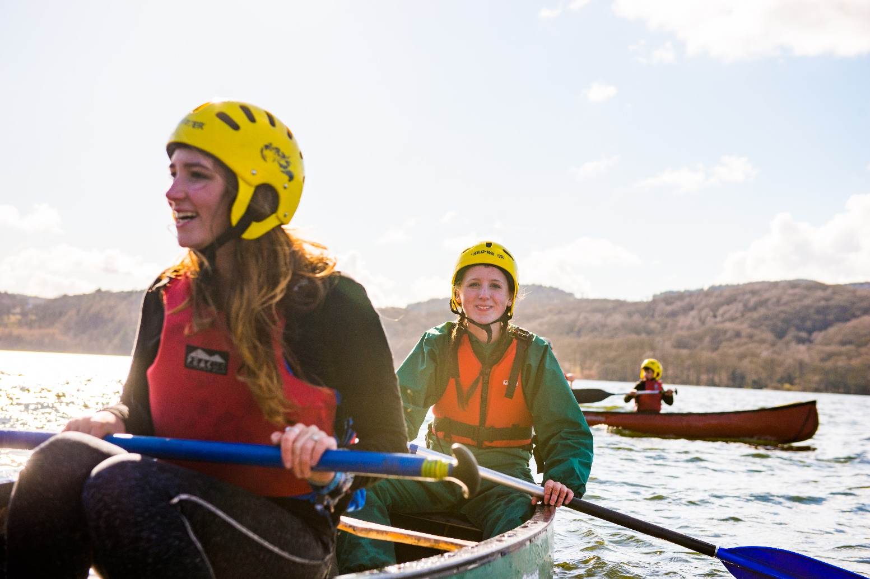
County Youth Commissioner

Information for anyone considering the role of County Youth Commissioner at XXX

About us
Overview of Youth Shaped
At Scouts, we provide young people with the opportunities to develop Skills for Life – including confidence to speak up, feeling empowered to make a difference and being ready to take the lead.

That’s what being youth shaped is all about. Our programmes and decisions are shaped by young people, working in partnership with volunteers.

The difference you’ll make to young people
Youth commissioners help young people to make their voices heard and improve scouts for the better. You’ll be working to help more young people get the opportunity to speak up and take the lead – skills and experiences that set them up for the future. And in the process, you’ll get to learn plenty of new skills yourself too.

The current vacancy
We’re currently looking for a County Youth Commissioner to work with us at XXX scouts.
What does a youth commissioner do?
Youth Commissioners are volunteers responsible for driving youth shaped in their local area. They support volunteers, shape the programme, influence decisions that we make at Scouts and take the lead.

They are aged 18-25 at appointment and enable volunteers to embed the ideas and decisions of young people into local scouting.

They play a key role in the leadership and management of the County. They need to motivate both volunteers and young people. Responsilities in a youth commissioner role vary, but are likely to include:

- Help to make sure that the County programme is shaped by young people.
- Create opportunities for young people to provide feedback (often through a County Youth Forum).
- Promote the YouShape award and top awards.
- Support the District Youth Commissioners in their County, bringing them together to support each other, share ideas, and work towards a shared vision.
- Inspire and motivate young people in the County and make sure they know about all the different opportunities available to them in Scouts, including what they can do when they turn 18.
- Influence decisions that are made in the County as a member of the County Executive Committee, making sure that young people are at the heart of decisions.

Support every step of the way
County Youth Commissioners are line managed by the County Commissioner, who will help you set objectives and work with you towards improving local youth shaped scouting.

And the UK Youth Commissioner team are also here to support County Youth Commissioners - running inductions, events, webinars and more. So you’ll have support available whenever you need it.

What you’ll get from the role
Being a Youth Commissioner is an amazing role. As well as helping to drive youth shaped locally and giving young people a say, you’ll also be learning loads of new skills and having fun along the way.
You’ll get experience and develop skills that will look seriously impressive on a CV or university application - things like teamwork, communication and organisation, but also experience with governance, working with young people and leading others.
Across the UK, there are now over 600 Youth Commissioners doing amazing things. Ready to join them?

“Applying to become Youth Commissioner was genuinely one of the best decisions I’ve ever made. Through this role I’ve learned so much, got to work with a really great team, and made a big difference to the experience of young people in Scouts”.

“I never thought I’d get the role, but I decided to apply anyway just in case. 3 years later, I’m so glad I did. I’d recommend applying to everyone who is considering it”.

“What surpised me most when starting the role was the amazing support that was available from my local team and other youth commissioners. I’ve made new friends and gotten to work with some great people”.

“Seeing the difference this role makes to young people is the best part. I’ve watched young people speak up and shape their scouting experience for the better – and I couldn’t be more proud”.

How the process works
Process
Thank you for your interest in volunteering.
You can apply for the role yourself using the application form or nominate someone else using the nomination form. Nominated people are under no commitment to apply unless they wish to.
Shortlisting will be based solely on the information provided by each candidate in their application form. All applications should address the requirements of the role, as laid out in the role description and person specification

Key dates
The closing date for applications is XXX
Interviews will be held on the XXX at XXX

Further information
For more information, or for an informal chat about this vacancy, please contact:
Name:
Phone:
Email:

All about the role - County Youth Commissioner

Outline role description
Outline:
As a member of the County Leadership Team the County Youth Commissioner works in partnership with the County Commissioner and Chairperson of the County Executive Committee. The role is to ensure that young people from 6 – 25 years are involved and engaged in every decision that shapes their Scouting experience locally and to empower young people to share their ideas and have a meaningful voice in planning, implementing and reviewing their programme and opportunities.
Responsible to:
County Commissioner
Responsible for:
Deputy County Youth Commissioner(s) (if appointed), County Youth Forum (or similar) Lead,
Main Contacts:
Young people within their County, County Commissioner, County Youth Forum Lead, Deputy County Youth Commissioners, Deputy County Commissioners, District Commissioners, Assistant County Commissioners, County Chairperson, members of the County Executive Committee and its sub-committees, District Youth Commissioners and other County Youth Commissioners.
Appointment requirements:
18-25 years old at the time of appointment. Must successfully complete the appointment process (including acceptable personal enquiries and acceptance of The Scout Association's policies). During the five months of Provisional Appointment the relevant Getting Started modules must be completed. A Wood Badge must be completed during the Appointment, and ongoing safeguarding and safety training must be completed.

Main Tasks
- Champion, encourage and lead the work to ensure that, by 2025, scouting in the County is shaped by young people in partnership with adults. This will be achieved by working in partnership and collaboration and with the County Commissioner, County Chairperson, District Youth Commissioners and County Team
- Support youth shaped scouting in the programme
- Embed young people in local decision making
- Develop young people in the County
- Wider engagement with the work of the County

Note: Some of the tasks for which the County Youth Commissioner is responsible may be delegated to others in the County, including a Deputy County Youth Commissioner, if appointed.

Person Specification
Age
18 – 25 years old | Essential
Skills required
Ability to lead and motivate teams | Essential
Excellent communication skills | Essential
Able to work well in meetings | Essential
Excellent presentating and facilitating skills | Essential
Able to work with young people and adults | Essential
Able to take on responsibility and meet deadlines | Essential
Knowledge required
An understanding of the structure and principles of The Scouts | Desireable
Previous experience of scouting | Desireable
Qualities required
Accept the policies and rules of The Scouts | Essential
Willingness to become a member, take The Scout Association Promise and  wear the Scout Uniform | Essential
Accept and promote Scouting's fundamentals and the implementation  of the youth programme | Essential
Have enough time available to commit to the role | Essential

