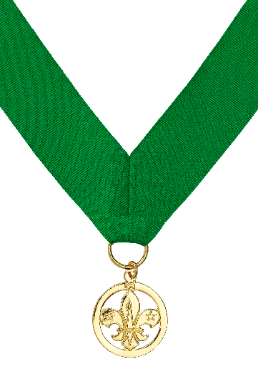
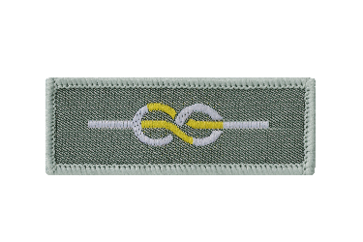
Chief Scout’s Commendation for Good Service and Award for Merit nomination form
The purpose of this form is to nominate an individual for an award. This form is used to collect personal data about you and the individual being nominated.

We take personal data privacy seriously. The data you provide is managed and carefully kept in line with our Data Protection Policy. This personal data may be shared with other relevant Scout members for the purpose of assessing the award nomination. Make sure the nomination form is only shared locally in accordance with the guidance below.

Details of successful awards will be uploaded to an individual’s Compass record and published annually on scouts.org.uk/awards. The UK Headquarters Awards Team will share relevant data with other UK Headquarters teams for appropriate national event invitations. The UK Headquarters Awards Team will also securely store (electronically) the details for one year from the end of the awarding process (or longer if required for national event invitations), before they’re passed to the UK Headquarters Heritage Team for their records. Local nomination forms should be kept for 12 months in line with UK Headquarters timeline, and securely destroyed after this period. This is in case they’re needed for further queries from the Awards Team.

Last updated 17/08/2021
scouts.org.uk/awards
#SkillsForLife

Once the form is completed by the nominator

For all countries:

- If the nominee holds their primary appointment in a Group/District, this form should be sent to the relevant District Commissioner for a decision.

- If the nominee is a District Commissioner, or their primary appointment is in a County/Area, this form should be sent to the relevant County/Area/Region (Scotland) Commissioner for a decision.

- If the nominee is a County/Area/Region (Scotland) Commissioner, this form should be sent to the relevant Regional Commissioner (England/Wales) or the Country Headquarters (Northern Ireland/Scotland) for a decision.

For England/Wales:
- If the nominee is a Region Commissioner, this form should be sent to the Chief Commissioner of England/Wales for a decision.
For Headquarters staff:

- If the nominee is a Headquarters staff member, this form should be sent to the relevant member of the Senior Leadership Team (UK Headquarters) or lead staff member (Country Headquarters) for a decision.

For Headquarters volunteers:

- If the nominee is a national volunteer, this form should be sent to either the relevant member of Team UK, Chair/Vice Chair of the UK Trustee Board or the Chair of the relevant UK Board Subcommittee for a decision.

Note: Commissioners can delegate the decision making process to a Deputy or their Local Awards Advisory Group.

Contact details are available from the Scout Information Centre (Info.Centre@scouts.org.uk or 0345 300 1818).

Nominee’s details
Please note: The 'Name' listed on Compass (not 'Known As') is used for certificate printing so if a 'Name' amendment is required please email this request to awards@scouts.org.uk.
Membership number Click/tap here to enter membership number
Name Click/tap here to enter name (Forename Surname)
Location (County/Area/Region) Select County/Area/Region
Location (District) Select District
Award nomination Select award
Award preference Select preference

Nominator’s details
A minimum of one nominator and one approver (who are different individuals) must provide support for this nomination before the award decision is submitted to UK Headquarters.

A nomination for these awards can be initiated by anyone but then must be approved by the relevant individual as laid out in the ‘Once the form is completed by the nominator’ section.
Membership number (if relevant) Click/tap here to enter membership number
Name Click/tap here to enter name (Forename Surname)
Email Click/tap here to enter email address

Checklist
The nominator must check the below boxes to confirm the individual being nominated meets the following criteria:

☐ The nominee holds a volunteer appointment as a member or associate member of the Scouts.
☐ The nominee has enough service for the award they’re being nominated for:
- Chief Scout’s Commendation for Good Service requires a minimum of five years good service.
- Award for Merit requires a minimum of 12 years (exceptionally, 10 years) outstanding service.
- (Roles that don’t accrue service can’t be counted for this.)

☐ The nominee has a valid disclosure (if relevant for their active roles).

☐ The nominee has not received a Good Service Award in the last five years.
☐ The nominee does not already have the award they are being nominated for.
☐ The nominee has completed all mandatory training (including Wood Badges) relevant to all active roles (or is within three years of appointment to the active roles):
- If the nominee was previously awarded a Wood Badge for the same role as one of their active roles, Compass must be updated to reflect the training of the active role as being up-to-date.

Reason for making the nomination

A citation for the Chief Scout’s Commendation for Good Service and the Award for Merit is not essential, however, it’s helpful to include the reasons you wish to nominate this individual so it’s easier for a decision to be made concerning the nomination. Try to include a summary, with examples, about their role and achievements. Citations should be based on fact and the personal data given should be limited to only what is necessary to make the nomination. (For guidance on citation writing, please visit scouts.org.uk/awards.)

Click/tap here to enter text

Click/tap the placeholder below to add an image (if relevant)

Approver’s details
A minimum of one nominator and one approver (who are different individuals) must provide support for this nomination before the award decision is submitted to UK Headquarters.

Only those with a role listed in the dropdown list below can approve the nomination. Please refer to ‘Once the form is completed by the nominator’ section for clarification on who this is.
☐ If nominee has roles in multiple locations, I’ve consulted the relevant line manager(s) before reviewing the form.
Membership number Click/tap here to enter membership number
Name Click/tap here to enter name (Forename Surname)
Role Select role
Signature Click/tap here to enter name (Forename Surname) as your signature
☐ Check the box to authorise the form
Date Select or click/tap here to enter date
By entering your name and checking the box above, you authorise this form. If a fraudulent nomination is submitted, the matter will be drawn to a suitable line manager’s attention who will be advised to take appropriate action.

Once approved, submit award decision to UK Headquarters using the Good Service Award completion form.

