Example asbestos management plan

This document is designed to give your Group, District etc. a sound starting point for fulfilling your statutory obligations and managing asbestos. It may also be helpful to refer to the Managing Asbestos guidance and FS320010 Managing a Safe Scout Premises.

Once you have a plan in place, consider using a licensed contractor to carry out any necessary remedial actions. Be realistic; you may have to prioritise these happening, but always reinforce your decisions by recording how you assessed them and the relative risk.

You may already be carrying out a regular check but not recording it. This example plan will give you a tried and tested format to do this. Make sure any records are filed safely and can be found by those needing access to the information.

Asbestos management plan

Premises: 1st Alphatown Scout Group HQ
Delta Avenue,
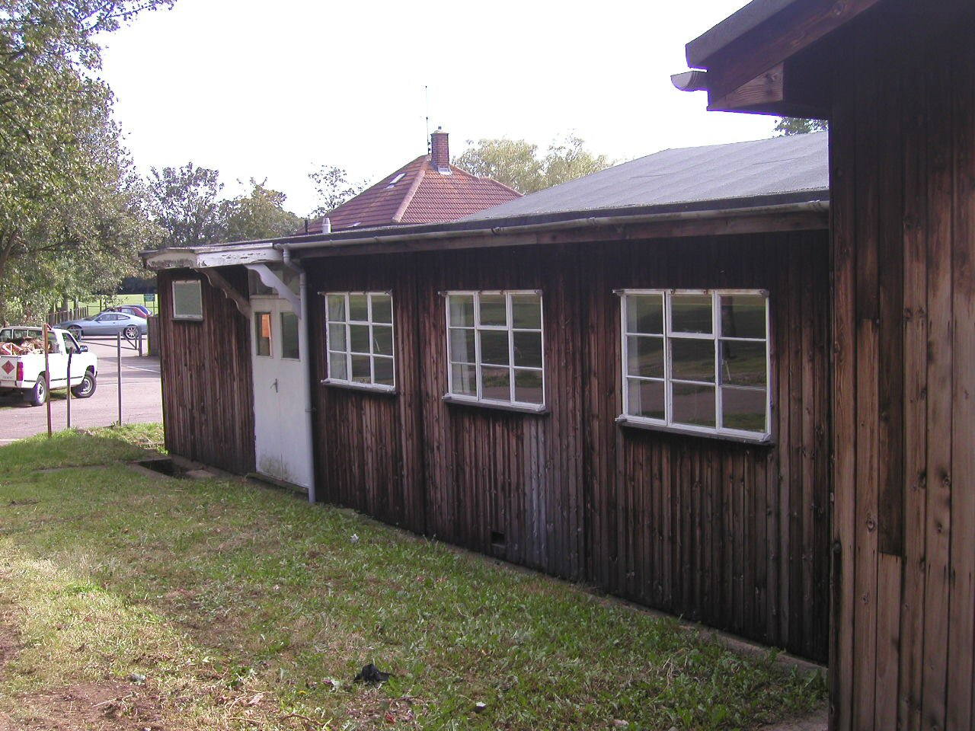
Alphatown,
AB12 3CD.

Date plan produced: 31 December 2011

Review date: November 2024

Issued to: Group Chair of Trustees - Steve Brown, Group Lead Volunteer - Kate Smith

Copied to: Building manager, member of the Trustee Board with some relevant experience (if you have one)

Contents

- Introduction
- Responsibilities
- Summary of location of asbestos
- Asbestos risk assessment
- Action plan
- Procedures

Appendix A: Record of inspections on asbestos containing materials (ACMs)
Appendix B: Record of contractor’s inspection of register
Appendix C: Asbestos survey report. Type 2 survey, Browns’ (Alphatown Limited) dated 22 April 2011

Introduction

Asbestos is a microscopic mineral fibre that is so small that it can’t be seen with the naked eye. Once disturbed, fibres can remain in the air for hours. If fibres are inhaled, they can cause serious health hazards which might not become apparent for years.

Note: Asbestos should only be disturbed or maintained by specialist personnel, who may be a licensed contractors, working under strictly controlled conditions.

Those responsible (the Trustees) for any non-domestic premises are required to manage them in respect of any asbestos they may contain. This requires knowing what asbestos containing materials (ACMs) may be present, their location and condition. The simplest way to do this is to have a survey undertaken by a professional, such as a person who holds a BOHS P402 or equivalent.

The contents of your survey are then used to produce a management plan, like this one, to help the Trustees to manage the ongoing condition of and access to any ACMs. This should include regular checking of the condition of the ACMs and controlling any building or repair works to ensure this is not disturbed, except by specialists under controlled circumstances.

2 Responsibilities

Responsible Person
This is a suggested text and will vary depending on circumstances and the set up.

Overall and final responsibility for safety matters within the Group’s premises is that of the Chair of the Trustee board . The Group Lead Volunteer will be responsible in the absence of the Chair.

Trustee Board
The Trustee Board working with the Group Lead Volunteer has responsibility for the safety of all members in their Group. They are responsible for ensuring that all volunteers and members in their Group comply with their responsibilities detailed below and that any improvements and repairs to the premises carried out at the Group headquarters are safe and follow good working practice at all times.

Volunteers and other adults
All volunteers and adults in the Group are responsible for safety provisions, including the following:

- Ensuring that all persons responsible to them are aware of potential hazards and that suitable controls are in place
- Ensuring that all adults and young people understand and comply with the operational guidelines for any activity, including improvements and repairs to premises;
- Ensuring all safety issues, including accidents and incidents, are reported to the District Lead Volunteer and, if necessary, the Trustee Board, following the procedures laid down in chapter 7 of POR.

Operational responsibility Contact Number

Group Chair (Responsible Person) Steve Brown 020 8123 4567
Group Lead Volunteer Kate Smith 020 8123 4567
Building manager John Williams 020 8123 4567
District Lead Volunteer David Jones 020 8123 4567
Persons carrying out monitoring and maintenance Members of the Scout Group

The Group Chair and the Group Lead Volunteer (working with the building manager) are responsible for ensuring that this plan is put into effect and to make others aware of it, as necessary. They must also ensure that the plan is reviewed at least every year.

3 Summary of location, type and condition of asbestos

See survey (Appendix C) for details.

In summary, there is asbestos know to be in the following buildings and structures:

- Ground floor
- External
- Boiler room
- Roof tank room
- Meeting Room

The detail of this is found in Section 4.0 of the plan.

Example Asbestos risk management

Hazard: Asbestos containing materials (ACM)
Persons affected: Members, visitors, contractors, suppliers etc
Date of assessment: April 2020 Company conducting assessment: Browns (Alphatown) Limited

NADS – No Asbestos Detected in Sample NA – Presumed Not Asbestos (no sample taken)

Item | Location of ACM | Element | Type | Asbestos type | Condition | Risk level | Action | Inspection frequency
 | 1st Alphatown Scout Group HQ |  | Report AB676-88B
 | Ground floor
SO1 | Kitchen | Artex ceiling | - | NADS | - | - | No further action necessary | -
SO2 | Meeting room | Artex ceiling | Wellbound | Chrysotile | Small areas of damage | Medium | Repair | 6 monthly
SO3 | Main hall | Ceiling panels | Plasterboard | NA | - | - | No further action necessary | -
 | External
SO4 | Roof | Roof sheets | Cement | Chrysotile | Good | Low | Label and manage  Restrict access to roof | Yearly
 | Boiler room
SO5 | Boiler room | Boarding to back of boiler | - | NADS | - | - | No further action necessary | -
SO6 |  | Pipe flanges | Gasket | Chrysotile | Good | Very low | Label and manage | Yearly
 | Roof tank room
SO10 | Pipe to outside | Pipe | Cement | Chrysotile | Fair | Low | Label and manage | Yearly
SO11 | Room behind office - ceiling | Boarding | AIB | Amosite | - | - | Removed 2005 – see file for consignment note | -

5 Action plan

Given the condition and location of the ACMs and the use of the buildings, the decision has been taken to, where possible, Repair damage, leave the asbestos in place and manage it to prevent it being disturbed.

The following actions will be taken to manage the asbestos:

This plan will be reviewed annually by the Group Chair and the Group Lead Volunteer in consultation with the building manager.

The contents of this plan will be explained by the Group Chair and Group Lead Volunteer to all key adults. Any visitors, suppliers or contractors will have access to the asbestos management plan upon signing in. Records will be kept at the back of this plan (Appendix B).

Key adults will be briefed on what action to take if any asbestos is accidently disturbed (section 6).

Asbestos labels will be attached to all ACMs.

The Group Chair with the building manager will update the asbestos management plan if any asbestos is removed or treated.

The Group Chair with the building manager will ensure that no work is undertaken in any buildings that will disturb ACMs by either Joe Bloggs staff or contractors.

The condition of any ACMs will be monitored regularly in accordance with the asbestos management plan (Section 4.0). If it is found to be damaged or becoming friable, the area will be evacuated until the risks are reassessed and controlled.

The Group Chair or the building manager will make the asbestos survey report available to anyone who may need to see it (Appendix C) and record the action on “Contractors inspection of asbestos report”, (Appendix B)

Any works proposed which will affect the ACMs must first be approved by the Group Chair with the building manager after taking advice from a competent person. Contractors carrying out such work may need to be licensed and demonstrate their competence before being allowed to start. A full risk assessment and method statement will need to be produced, including disposal arrangements for the waste.

Any asbestos waste disposed of must be properly documented and copies of consignment notes filed with the building manager or Group Chair. Amendments to the asbestos management plan must be made.

6.0 Emergency procedures

Asbestos Containing Materials (ACM’s)
If damage occurs to any ACM:

- Stop activity or work immediately
- Keep people away from the area
- Undertake emergency decontamination of any people as below
- Lock off the affected area
- Inform the Group Chair or the building manager at the earliest opportunity
- Put up warning signs to keep people out of the area
- Arrange for competent person to undertake an asbestos sample and arrange analysis at a UKAS accredited laboratory,
- If positive sample
- Arrange for a competent contractor, probably a licensed contractor to remove or repair the damage.
- You may need to arrange for asbestos air testing by a UKAS accredited analyst

Emergency Decontamination
If dust or debris gets onto your clothing, wipe down clothing with damp rags, remove the outer clothing and place items in a sealed bag. Seal the bag, then bag again.

Using warm water and soap, wash all exposed skin in a sink and wash out sink and area.
If the sample is positive, arrange for removed clothing to be disposed of as contaminated asbestos waste. This must be via a licensed waste carrier and go to a licensed asbestos waste disposal point.

Ensure that an incident report form is completed and the District Lead Volunteer is informed.

Appendix A

Asbestos inspection record. Inspected by.........................John Williams ................ on (date)...April 2020................
This sheet must be completed each time the asbestos containing Material (ACM) is inspected. Any deterioration or damage identified must be brought to the attention of the building manager and the Group Chair immediately by the person carrying out the inspection.

Date | Item (see Section 4.0) | Location of ACM | Findings/condition  (note any damage/deterioration) | Inspected by | Necessary remedial action | Responsible Person | Date to be completed by | Date completed
 | SO2 | Ceiling meeting room | Small areas of damage | John Williams | Seal and glue protective boarding over | John Williams | 1 month
 | SO4 | Roof - roof sheets | Good condition | John Williams | Nil
 | SO6 | Boiler room  pipe flanges - gasket | Good condition | John Williams | Nil
 | SO10 | Roof tank room – cement pipe | Good condition | John Williams | Nil

Appendix B

Record of contractors’ inspection of asbestos report

This sheet should be signed by all those carrying out work on the premises (including volunteers, cleaners and staff). Persons signing this sheet are signing to say that they have seen the asbestos management plan and survey and checked whether there is any known or presumed asbestos in the area in which they will be working.

If they encounter suspected asbestos containing materials (ACM) that have not been previously identified they will immediately stop work, inform the building manager or Group Chair and seek their further instructions.

Note: the asbestos survey was a Management & Maintenance (non-intrusive) so there is a possibility that there may be further ACM’s which were inaccessible at the time of the survey.

Date | Company name | Work being carried out/location on site | Valid Asbestos Awareness held | Name of person who has inspected the asbestos report | Signature
30 June 2011 | Nice floor company | New floor being laid in main hall and meeting room | √ | Steve Smith

