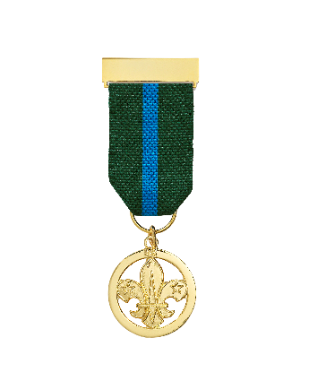
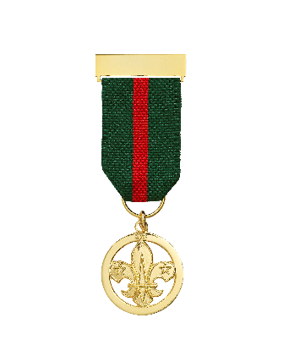
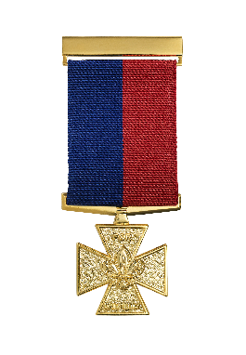
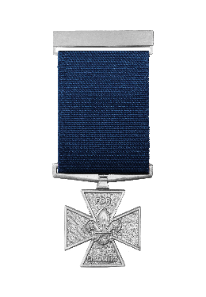
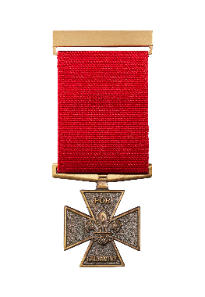
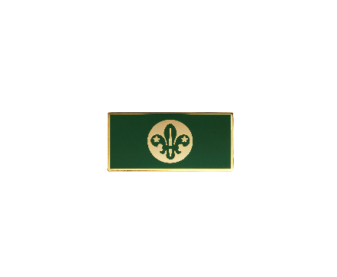
Meritorious Conduct, Gallantry, Cornwell Scout Badge and Chief Scout’s Personal Award nomination form
The purpose of this form is to nominate an individual for an award. This form is used to collect personal data about you and the individual being nominated.

We take personal data privacy seriously. The data you provide is managed and carefully kept in line with our Data Protection Policy. This personal data may be shared with other relevant Scout members for the purpose of assessing the award nomination. Make sure the nomination form is only shared locally in accordance with the guidance below.

Details of successful awards will be uploaded to an individual’s Compass record and published annually on scouts.org.uk/awards. The UK Headquarters Awards Team will share relevant data with other UK Headquarters teams for appropriate national event invitations. The UK Headquarters Awards Team will also securely store (electronically) the details for one year from the end of the awarding process (or longer if required for national event invitations), before they’re passed to the UK Headquarters Heritage Team for their records. Local nomination forms should be kept for 12 months in line with UK Headquarters timeline, and securely destroyed after this period. This is in case they’re needed for further queries from the Awards Team.

Last updated 12/03/2024
scouts.org.uk/awards
#SkillsForLife

Once the form is completed by the nominator

Branches

- If the nominee is a District Commissioner - Branch, or their primary appointment is in a District/Branch, this form should be sent to the relevant Branch Commissioner for support (Supporter A), then to the Lead Volunteer of the Branches for additional support (Supporter C).

- If the nominee is a Branch Commissioner, this form should be sent to the Lead Volunteer of the Branches for support (Supporter C).

- If the nominee is the Lead Volunteer of the Branches, this form should be sent to the Chief Volunteer for International for support (Supporter C).

British Scouting Overseas
- If the nominee holds their primary appointment in a Group/District, this form should be sent to the relevant District Commissioner for support (Supporter A), then to the Area Commissioner for additional support (Supporter C).

- If the nominee is a District Commissioner, this form should be sent to the relevant Area Commissioner for support (Supporter C).

- If the nominee is an Area Commissioner, this form should be sent to the Chief Volunteer for International for support (Supporter C).

England/Wales
- If the nominee holds their primary appointment in a Group/District, this form should be sent to the relevant District Commissioner for support (Supporter A), then to the relevant County/Area Commissioner for their additional support (Supporter C).

- If the nominee is a District Commissioner, or their primary appointment is in a County/Area, this form should be sent to the relevant County/Area Commissioner for support (Supporter C).

- If the nominee is a County/Area Commissioner, this form should be sent to the relevant Region Commissioner for support (Supporter C).

- If the nominee is a Region Commissioner, this form should be sent to the relevant Country Chief Volunteer for a decision (Supporter C).

Headquarters staff
- If the nominee is a UK Headquarters staff member, this form should be sent to the relevant member of the Executive Leadership Team (UK Headquarters) for support (Supporter B), then to the Chief Executive Officer (UK Headquarters) for additional support (Supporter C).

- If the nominee is a Country Headquarters staff member, this form should be sent to the lead staff member (Country Headquarters) for support (Supporter C).

Headquarters volunteers
- If the nominee is a national volunteer, this form should be sent to the relevant member of the UK Leadership Team or the Chair of the relevant UK Board Subcommittee for support (Supporter B), then to either the UK Chief Volunteer or the Chair/Vice Chair of the UK Trustee Board for additional support (Supporter C).

Northern Ireland/Scotland
- If the nominee holds their primary appointment in a Group/District, this form should be sent to the relevant District Commissioner for support (Supporter A), then to the relevant County/Region (Scotland) Commissioner for their additional support (Supporter B), then to the relevant Country Chief Volunteer for further support (Supporter C).

- If the nominee is a District Commissioner, or their primary appointment is in a County/Region (Scotland), this form should be sent to the relevant County/Region (Scotland) Commissioner for support (Supporter B), then to the relevant Country Chief Volunteer for additional support (Supporter C).

- If the nominee is a County/Region Commissioner, this form should be sent to the relevant Country Chief Volunteer for a decision for support (Supporter C).

Approvers
- The National Awards Advisory Group act as the approver’s for this level of award (for all locations).

Notes
- Commissioners can delegate the decision making process to a Deputy or their Local Awards Advisory Group.
- Contact details are available from the Scout Support Centre (support@scouts.org.uk).

Nominee’s details
Please note: The 'Name' listed on Compass (not 'Known As') is used for certificate printing so if a 'Name' amendment is required please email this request to awards@scouts.org.uk.
Membership number (if relevant) Click/tap here to enter membership number or type ‘Youth Member’
Post Code (if youth member) Click/tap here to enter post code
Current Age Select age
Name Click/tap here to enter name (Forename Surname)
Location: County/Area/Region (Scotland) or Region or National SASU or Country: Select location
Location District Select Location
Award nomination Select award
Award preference Select preference

Nominator’s details
A minimum of one nominator and one supporter (who are different individuals) must provide support for this nomination before submitting it to UK Headquarters.

A nomination for these awards can be initiated by anyone but then must be supported by the relevant individuals as laid out in the ‘Once the form is completed by the nominator’ section.

Membership number (if relevant) Click/tap here to enter membership number
Name Click/tap here to enter name (Forename Surname)
Email Click/tap here to enter email address

Nominee’s previous awards
(For adult members only) Please list the most recent previous awards achieved by the nominee. (This information can be found on their Compass record).

Type of award Name of award Date
Length of Service Award Select award Select or click/tap here to enter date
Good Service Award Select award Select or click/tap here to enter date

(For all nominees) Please list any previous Meritorious Conduct/Gallantry awards achieved by the nominee.
Name of award Date
Select award Select or click/tap here to enter date
Select award Select or click/tap here to enter date

(For all nominees) Awards received in the last 12 months
If the nominee has received a Commissioner’s Commendation, a Good Service Award, a Meritorious Conduct/Gallantry Award, the Cornwell Scout Badge or a Chief Scout’s Personal Award in the last 12 months, you must provide a brief explanation as to why the previous award was given, because two different Scouts awards shouldn’t be awarded for the same accomplishments.
Click/tap here to enter text

Nominee’s previous/current roles (adult members only)
To ensure the relevant approvers can make an informed decision on this nomination, please provide a screen shot of the nominee’s current and previous adult appointments as listed on Compass.
Click/tap the placeholder below to add the required image

Citation concerning the nominee
Provide a detailed summary below explaining, with examples, why the nomination is being made. Citations should be based on fact and the personal data given should be limited to only what’s necessary to make the nomination. (For guidance on citation writing, please visit scouts.org.uk/awards.)

Date of incident or when the personal challenge became known. Select or click/tap here to enter date

Reason for the award nomination
Outline the incident or condition that’s been brought to your attention. Please be as specific as possible about dates and include as much detail as possible to help the National Awards Advisory Group understand the situation.
Click/tap here to enter text

Involvement in Scouts
Outline what the nominee does in/for Scouts and their usual character.
Click/tap here to enter text

Key achievements and outcome
What has the nominee achieved (for themselves or others) by dealing with the incident or despite their condition?
Click/tap here to enter text

Personal challenges
Think about the main challenges or risks that the nominee has had to overcome. For acts of bravery did they put their life at risk, and if so, how? If undergoing treatment for a medical condition, how has this affected them and what is the long-term prognosis?
Click/tap here to enter text

Other community recognition
Outline any other recognition the nominee has received relating to the incident or condition described above. Examples could include: recognition from the emergency services or other organisations. Please also list the name and dates of any related awards received by the nominee.
Click/tap here to enter text

Witness statements/evidence
Detail all external support for this nomination. Examples could include: statements from eye-witnesses, the emergency services, doctors or medical specialists or newspaper cuttings etc.
Click/tap here to enter text

Click/tap the placeholder below to add an image (if relevant)

Any other relevant information
Click/tap here to enter text

Supporter’s details
A minimum of one nominator and one supporter (who are different individuals) must provide support for this nomination before submitting it to UK Headquarters.

Support will be required at all relevant levels before the nomination is sent to UK Headquarters. Please refer to ‘Once the form is completed by the nominator’ section for clarification on who needs to complete this section.

Parent/guardian consent (if nominee is under 18 years old)
Consent ☐ I consent to the information on/attached to this form being used as part of an award nomination and I understand that an award may/may not be approved.
Name Click/tap here to enter name (Forename Surname)
Email address Click/tap here to enter email address
(Your email address is requested so an appropriate national event invitation can be sent at the appropriate time if a Meritorious Conduct/Gallantry Award or the Cornwell Scout Badge is awarded to the nominee.)
Relationship to nominee Click/tap here to enter relationship
Click/tap here to enter supporting statement
Signature Click/tap here to enter name (Forename Surname) as your signature
☐ Check the box to authorise the form
Date Select or click/tap here to enter date
By entering your name and checking the box above, you authorise this form. If a fraudulent nomination is submitted, the matter will be drawn to a suitable line manager’s attention who will be advised to take appropriate action.

Supporter A (if required)
(To determine who needs to complete this section, refer to ‘Once the form is completed by the nominator’ section.)
☐ If nominee has roles in multiple locations, I’ve consulted the relevant line manager(s) before reviewing the form.
Membership number Click/tap here to enter membership number
Name Click/tap here to enter name (Forename Surname)
Role Select role
Click/tap here to enter supporting statement
Signature Click/tap here to enter name (Forename Surname) as your signature
☐ Check the box to authorise the form
Date Select or click/tap here to enter date
By entering your name and checking the box above, you authorise this form. If a fraudulent nomination is submitted, the matter will be drawn to a suitable line manager’s attention who will be advised to take appropriate action.

Supporter B (if required)
(This section is not required for nominations made under Branches, British Scouting Overseas, England or Wales)
(To determine who needs to complete this section, refer to ‘Once the form is completed by the nominator’ section.)
☐ If nominee has roles in multiple locations, I’ve consulted the relevant line manager(s) before reviewing the form.
Membership number Click/tap here to enter membership number
Name Click/tap here to enter name (Forename Surname)
Role Select role
Click/tap here to enter supporting statement
Signature Click/tap here to enter name (Forename Surname) as your signature
☐ Check the box to authorise the form
Date Select or click/tap here to enter date
By entering your name and checking the box above, you authorise this form. If a fraudulent nomination is submitted, the matter will be drawn to a suitable line manager’s attention who will be advised to take appropriate action.

Supporter C
(To determine who needs to complete this section, refer to ‘Once the form is completed by the nominator’ section.)
☐ If nominee has roles in multiple locations, I’ve consulted the relevant line manager(s) before reviewing the form.
Membership number Click/tap here to enter membership number
Name Click/tap here to enter name (Forename Surname)
Role Select role
Click/tap here to enter supporting statement
Signature Click/tap here to enter name (Forename Surname) as your signature
☐ Check the box to authorise the form
Date Select or click/tap here to enter date
By entering your name and checking the box above, you authorise this form. If a fraudulent nomination is submitted, the matter will be drawn to a suitable line manager’s attention who will be advised to take appropriate action.
The approver’s for this level of award are the National Awards Advisory Group.
If this award is successfully approved and processed by UK Headquarters, and you become aware that the award holder does not wish for their name to be included on the published Roll of Honour, please ask them to make the UK Headquarters Awards Team aware of this asap.

Certificate citation
In 50 words or less please detail below the citation that should be printed on the certificate (if an award is approved) concerning why the individual is being nominated.

Please note:
- All citations will begin with ‘In recognition of’.
- Do not include any dates or locations.
- Do not be too specific (e.g. write ‘battling a terminal illness’, rather than ‘battling cancer’).
- Do not use gender specifics, instead use ‘their’.

In recognition of… Click/tap here to enter certificate citation

Once nomination form is completed with appropriate support, email it to awards@scouts.org.uk

Completed nominations are processed by the UK Headquarters Scout Awards Team and reviewed by the National Awards Advisory Group on a quarterly basis. Please see scouts.org.uk/awards for further details relating to the timescales.

